**B 32 Vaishnavi Kothawade**



Bharati Vidyapeeth’s

**Institute of Management & Information Technology**

C.B.D. Belapur, Navi Mumbai – 400614

**Vision:**

Providing high quality, innovative and value-based education in information technology to build competent professionals.

**Mission**

M1. Technical Skills: To provide solid technical foundation theoretically as well as practically capable of providing quality services to industry.

M2. Development: -Department caters to the needs of students through comprehensive educational programs and promotes lifelong learning in the field of computer Applications.

M3. Ethical leadership: Department develops ethical leadership insight in the students to succeed in industry, government and academia.

**CERTIFICATE**

This is to certify that the journal is the work of **Ms. Vaishnavi Vidyadhar Kothawade** Roll No. **32** of MCA (Sem- 2 , Div: B ) for the academic year 2023 - 2025

Subject Code: **MCAL21**

Subject Name: **Artificial Intelligence & Machine Learning Lab**

Subject-in-charge Principal

Date: External Examiner

**Bharati Vidyapeeth's Institute of Managment & Information Technology MCA Semester II**

**Subject : MCAL21Artificial Intelligence and Machine Learning Lab**

**INDEX**

|  |  |  |  |  |  |  |  |  |  |
| --- | --- | --- | --- | --- | --- | --- | --- | --- | --- |
| **CO1** | Apply the basic concepts of artificial intelligence and its applications. | | | | | | | | |
| **CO2** | Experiment with basic and ensemble the machine learning algorithms and its applications. | | | | | | | | |
| **CO3** | Analyze dimensionality reduction techniques for feature extraction and  selection. | | | | | | | | |
| **CO4** | Develop models using appropriate machine learning algorithms for real world problems. | | | | | | | | |
| **Sr No.** | **DATE** | **Topic** | **CO** | **PO-PSO** | **Lab Perform (2)** | **Prese (3)** | **Unders &VIVA** | **Total (20)** | **Sign** |
| **I** |  | **Logic programming with Prolog** | | | | | | | |
| 1 |  | Implementation of Logic programming using PROLOG- DFS for water jug problem. | CO1 | PO1 , PO3,PO4,PO5,  PO10,PSO2 |  |  |  |  |  |
| **II** |  | **Introduction to Python Programming** | | | | | | | |
| 1 |  | Implement Basics of Python Programming. | CO1 | PO1 , PO3,PO4,PO5, PO10,PSO2 |  |  |  |  |  |
| 2 |  | Write a program to Implement ML NumPy library. |  |  |  |  |  |
| 3 |  | Write a program to Implement ML Pandas library. |  |  |  |  |  |
| 4 |  | Write a program to Implement ML SciPy, Matplotlib, Scikit  Learn library |  |  |  |  |  |
| **III** |  | **Supervised Learning** | | | | | | | |
| 1 |  | Write a program to implement Linear Regression. | CO2 | PO1, PO2, PO3, PO4, PO7, PSO1,PSO2 |  |  |  |  |  |
| 2 |  | Write a program to implement Logistic regression. |  |  |  |  |  |
| 3 |  | Write a program to implement KNN- classification. |  |  |  |  |  |
| **IV** |  | **Unsupervised Learning:** | | | | | | | |
| 1 |  | Write a program to implement K-Means clustering algorithm. | CO2 | PO1, PO2, PO3, PO4, PO7, PSO1,PSO2 |  |  |  |  |  |
| 2 |  | Write a program to implement K-medoid clustering algorithm. |  |  |  |  |  |
| **V** |  | **Classifying data using Support Vector Machines (SVMs)** | | | | | | | |
| 1 |  | Write a program to Classifying data using Support Vector Machines (SVMs).. | CO4 | PO1, PO2, PO3, PO5, PO7,  PO11, PSO1, PSO2 |  |  |  |  |  |
| **VI** |  | **Bagging Algorithm** | | | | | | | |
| 1 |  | Write a program to implement Bagging Algorithm Decision Tree. | CO3 | PO1, PO2,  PO4,PO7,PSO2 |  |  |  |  |  |
| 2 |  | Write a program to implement Bagging Algorithm Random  Forest. |  |  |  |  |  |
| **VI** |  | **Boosting Algorithms:** | | | | | | | |
| 1 |  | Write a program to implement Boosting Algorithms:  AdaBoost . | CO3 | PO1, PO2, PO4,PO7,PSO2 |  |  |  |  |  |
| 2 |  | Write a program to implement Boosting Algorithms:  Stochastic Gradient Boosting,. |  |  |  |  |  |
| 1 |  | **Deployment of Machine Learning Models** | CO4 | PO1, PO2, PO3,PO4, PO5,  PO7, PO10, PSO1, PSO2 |  |  |  |  |  |

# Practical No. 1

**Logic programming with Prolog**

**Problem Statement 1.1: Implementation of Logic programming using PROLOG-DFS for water jug problem.**

**Code:**

water_jug(X,Y):- X>4,Y<3,write('4L jug overflow.'),nl. water_jug(X,Y):- X<4,Y>3,write('3L jug overflow.'),nl. water_jug(X,Y):- X>4,Y>3,write('Both jugs overflow.'),nl.

water_jug(X,Y):- (X=:=0, Y=:=0,nl,write('4L:0 & 3L:3 (Action: Fill 3L jug.)'),YY is 3, water_jug(X,YY));

(X=:=0, Y=:=0,nl,write('4L:4 & 3L:0 (Action: Fill 4L jug.)'),XX is 4, water_jug(XX,Y)); (X=:=2, Y=:=0,nl,write('4L:2 & 3L:0 (Action: Goal State reached...)'));

(X=:=4, Y=:=0,nl,write('4L:1 & 3L:3 (Action: Pour water from 4L to 3L jug.)'),XX is X-3,YY is 3,water_jug(XX,YY));

(X=:=0, Y=:=3,nl,write('4L:3 & 3L:0 (Action: Pour water from 3L to 4L jug.)'),XX is 3,YY is 0,water_jug(XX,YY));

(X=:=1, Y=:=3,nl,write('4L:1 & 3L:0 (Action: Empty 3L jug.)'),YY is 0, water_jug(X,YY)); (X=:=3, Y=:=0,nl,write('4L:3 & 3L:3 (Action: Fill 3L jug.)'),YY is 3, water_jug(X,YY));

(X=:=3, Y=:=3,nl,write('4L:4 & 3L:2 (Action: Pour water from 3L jug to 4L jug untill 4L jug is full.)'),XX is X+1,YY is Y-1, water_jug(XX,YY));

(X=:=1, Y=:=0,nl,write('4L:0 & 3L:1 (Action: Pour water from 4L jug to 3L jug.)'),XX is Y,YY is X,water_jug(XX,YY));

(X=:=0, Y=:=1,nl,write('4L:4 & 3L:1 (Action: Fill 4L jug.)'),XX is 4, water_jug(XX,Y));

(X=:=4, Y=:=1,nl,write('4L:2 & 3L:3 (Action: Pour water from 4L to 3L jug untill 3L jug is full.)'),XX is X-2,YY is Y+2,water_jug(XX,YY));

(X=:=2, Y=:=3,nl,write('4L:2 & 3L:0 (Action: Empty 3L jug.)'),YY is 0, water_jug(X,YY)); (X=:=4, Y=:=2,nl,write('4L:0 & 3L:2 (Action: Empty 4L jug.)'),XX is 0, water_jug(XX,Y)); (X=:=0, Y=:=2,nl,write('4L:2 & 3L:0 (Action: Pour water from 3L jug to 4L jug.)'),XX is Y,YY is

X,water_jug(XX,YY)).

**Output:**

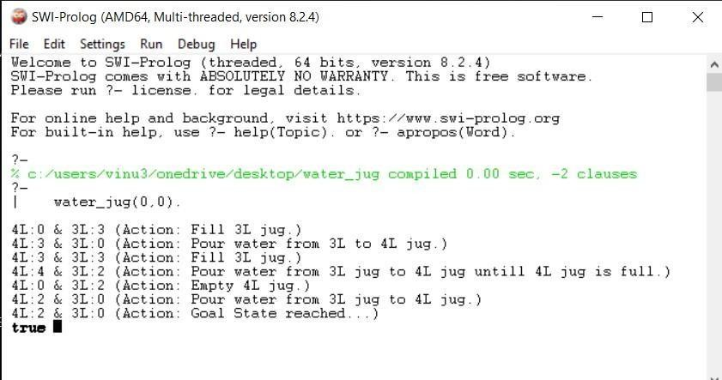

**Problem Statement 1.2: Implementation of Logic programming using PROLOG-DFS for Tower of Hanoi problem.**

**Code:** move(1,X,Y,_):-

write('Move top disk from') write(X)

write(' to ')

write(Y), nl. move(N,X,Y,Z):-

N>1,

M is N-1, move(M,X,Z,Y),

move(1,X,Y,_),

move(M,Z,Y,X).

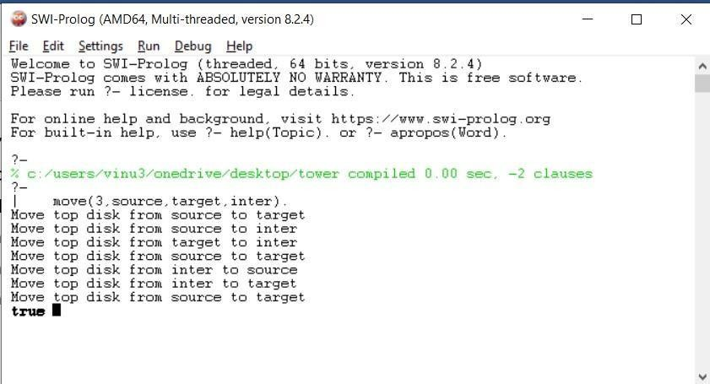**Output:**

# Practical No. 2 Introduction to Python Programming

**Problem Statement 2.1 : Implement Basics of Python Programming. Code:**

**Basics**

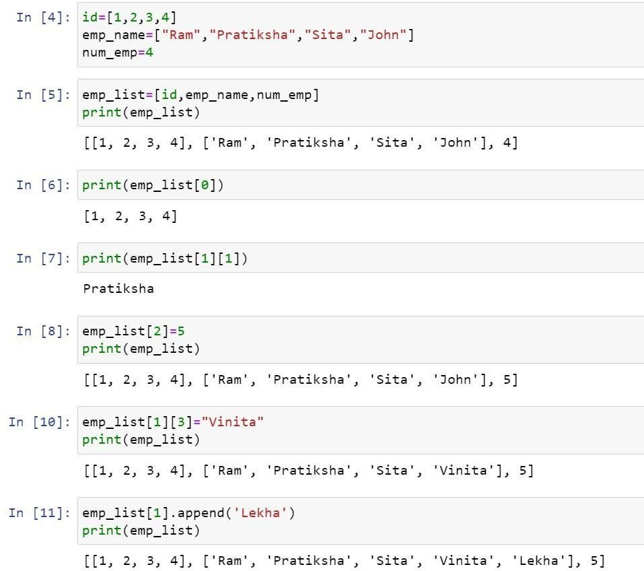

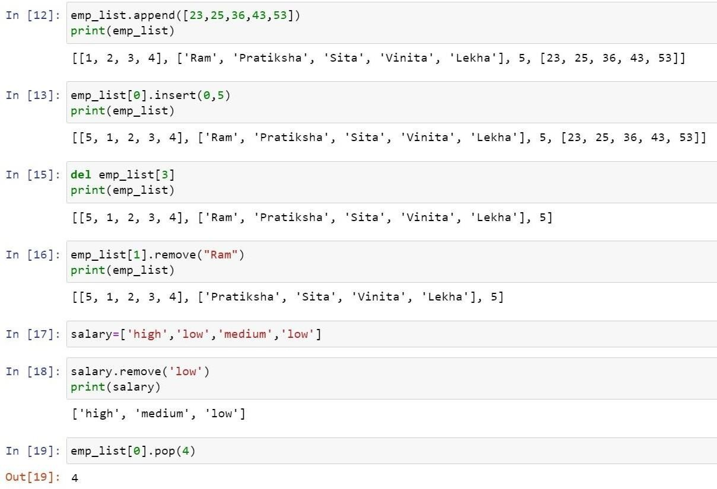

**Problem Statement 2.2: Write a program to Implement ML NumPy library-:**

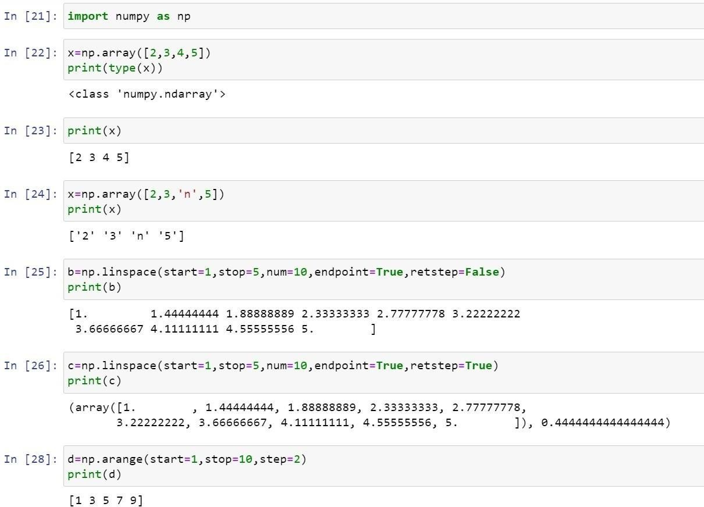

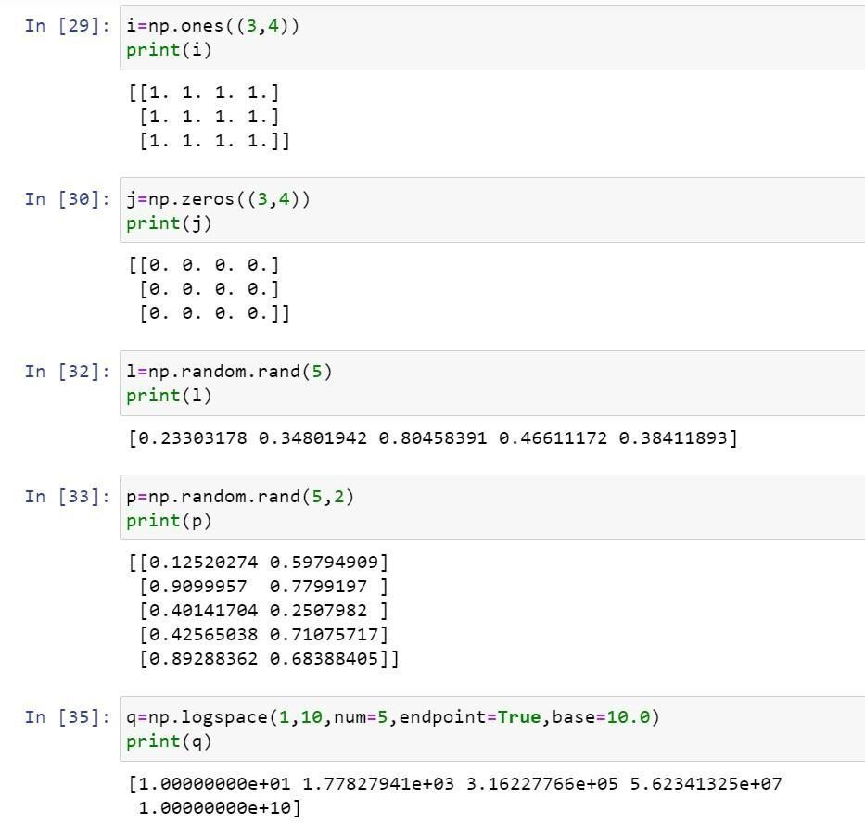

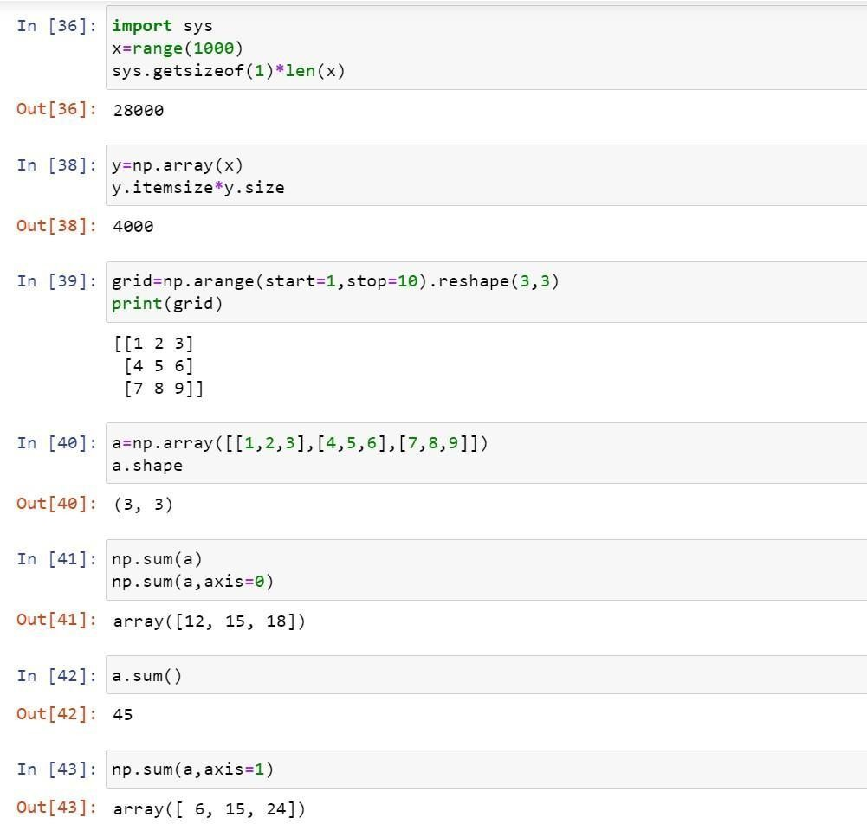

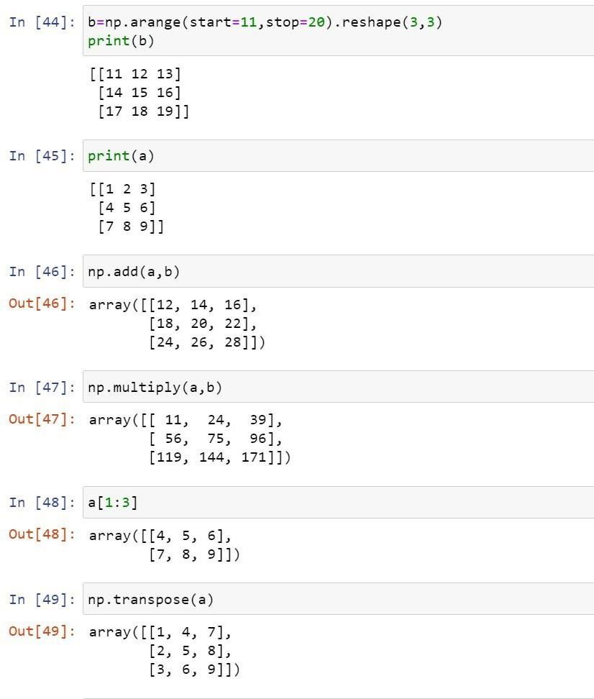

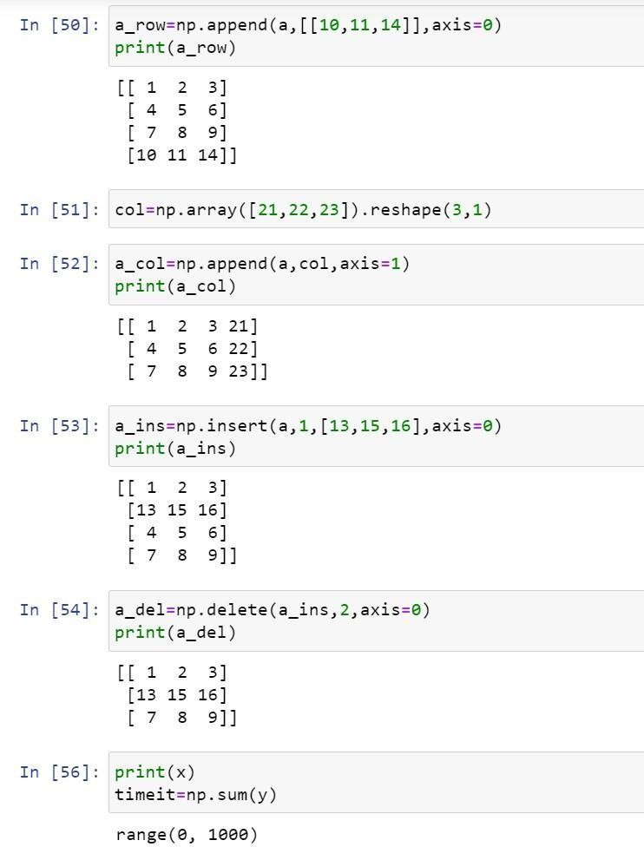

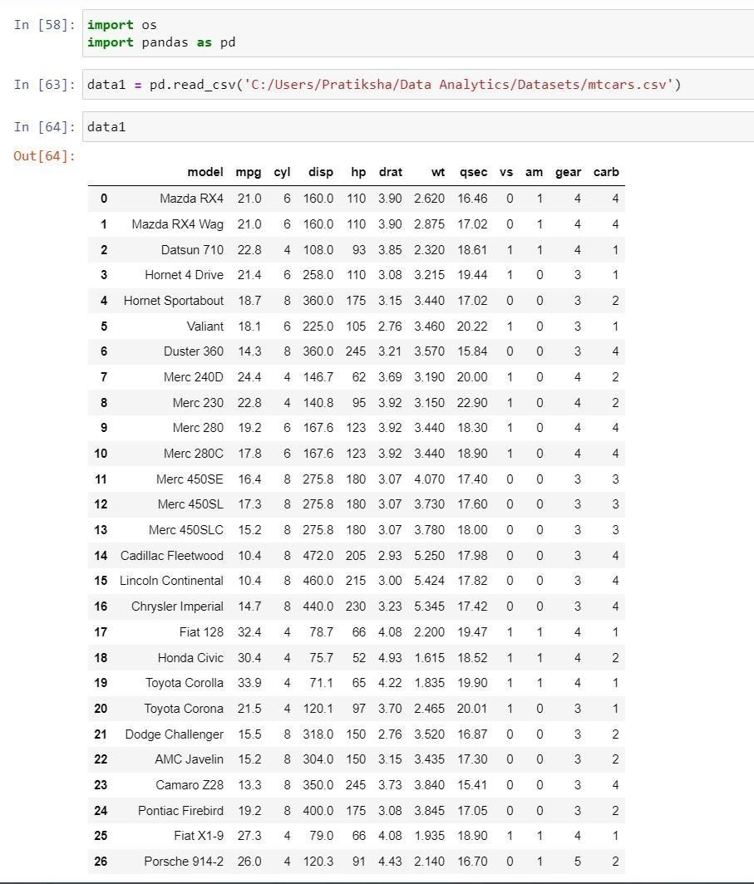**Problem Statement 2.3: Write a program to Implement ML Pandas library : First download the “mtcars.csv” dataset**

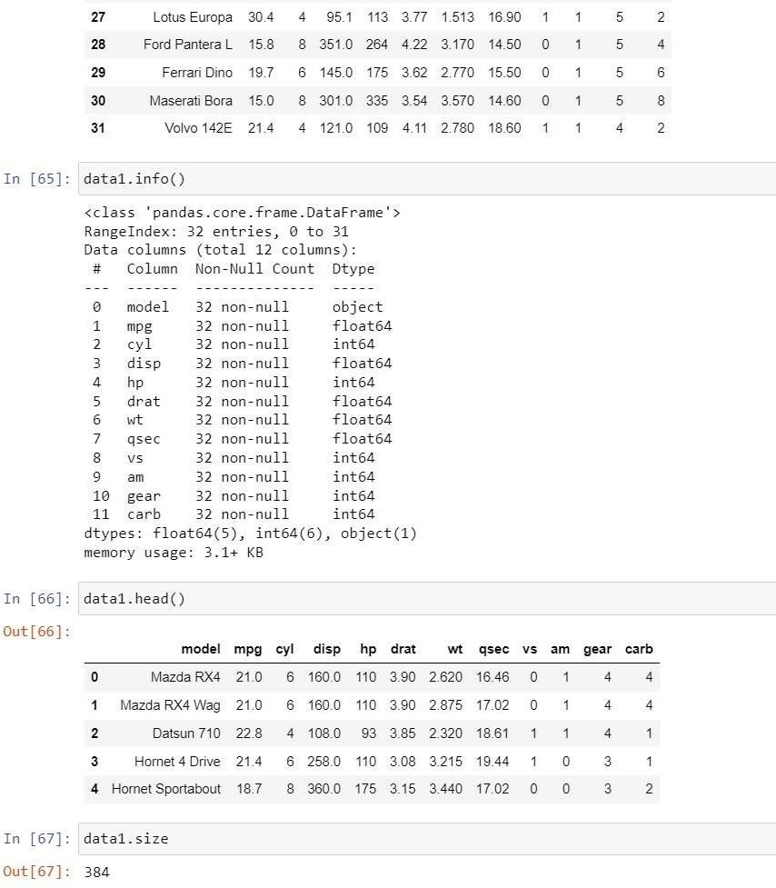

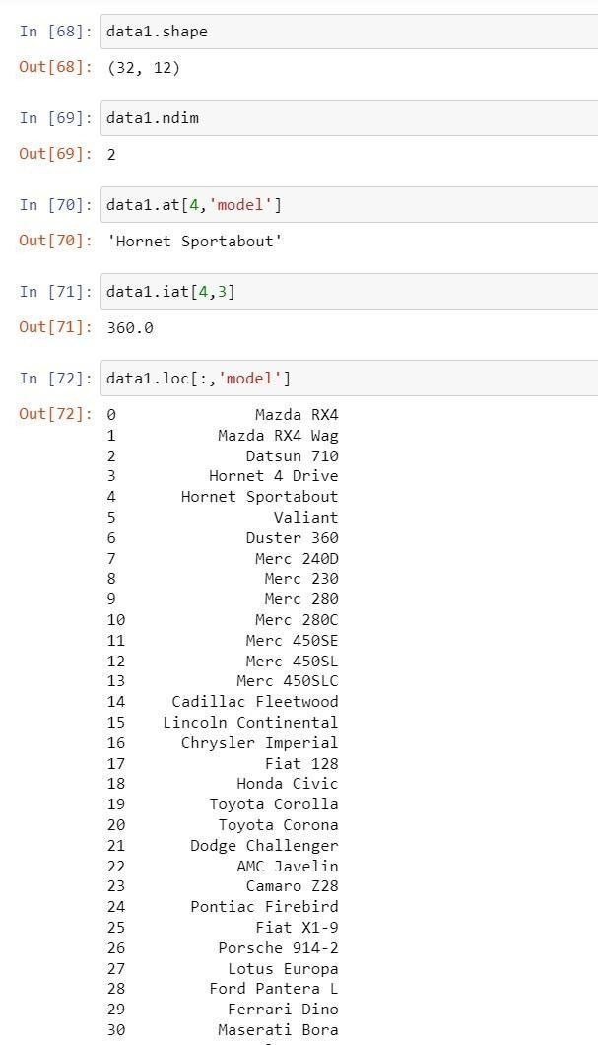

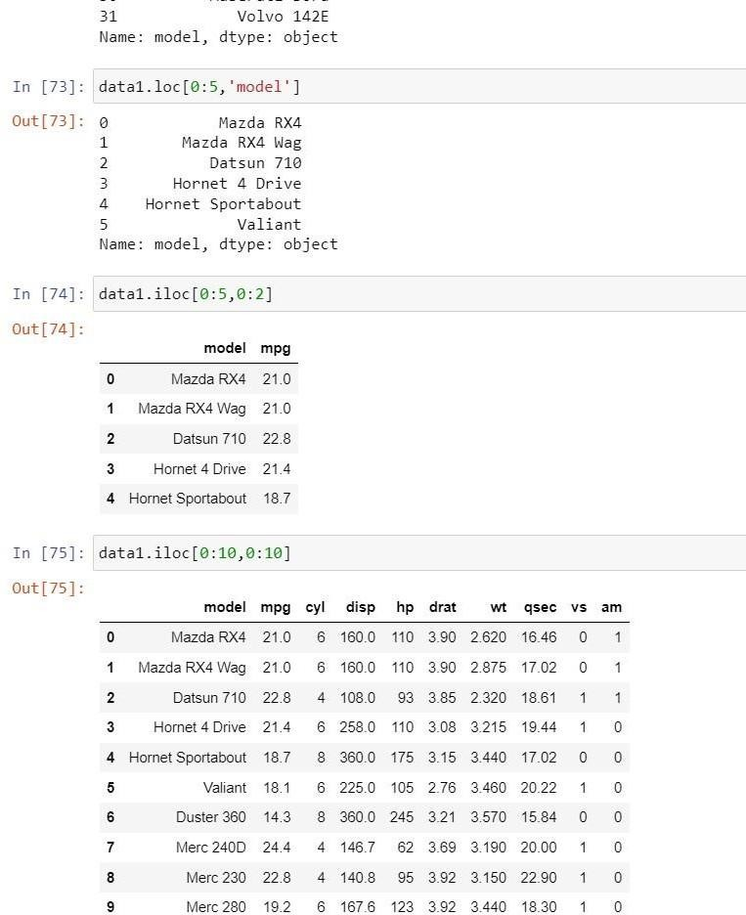

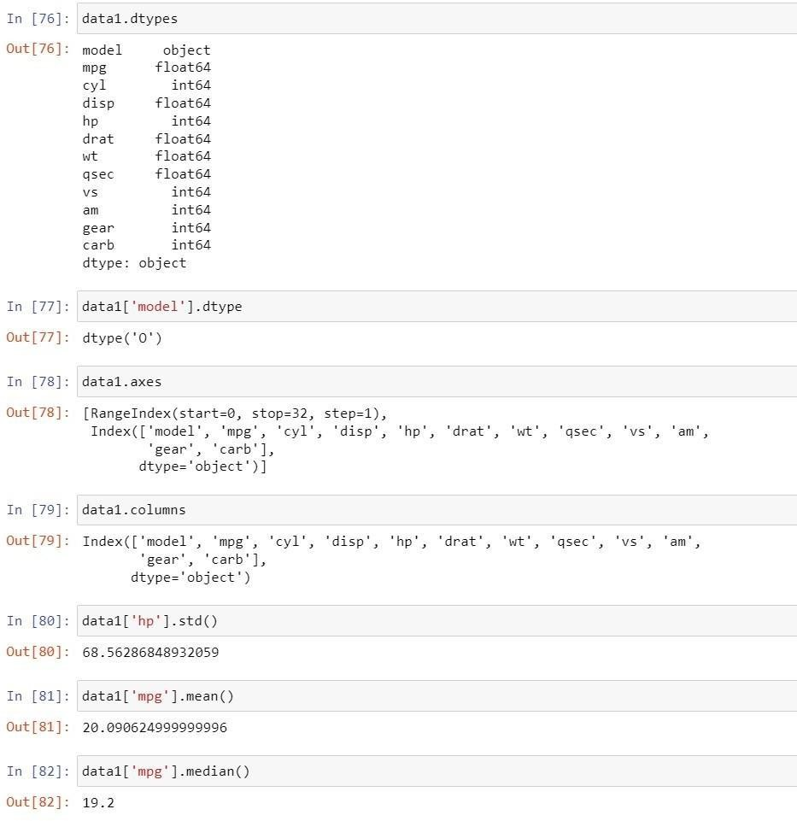

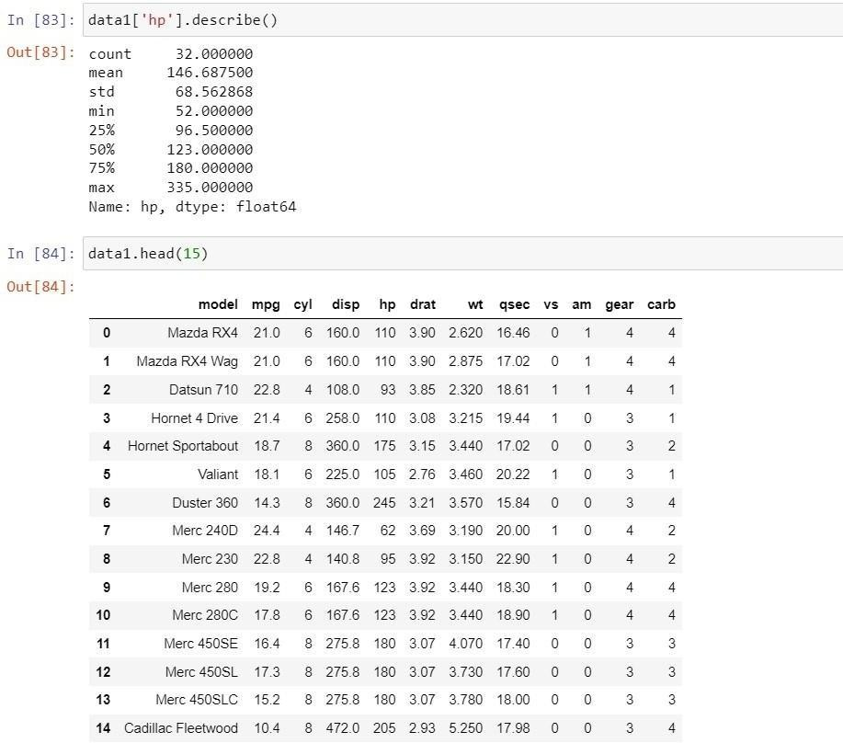

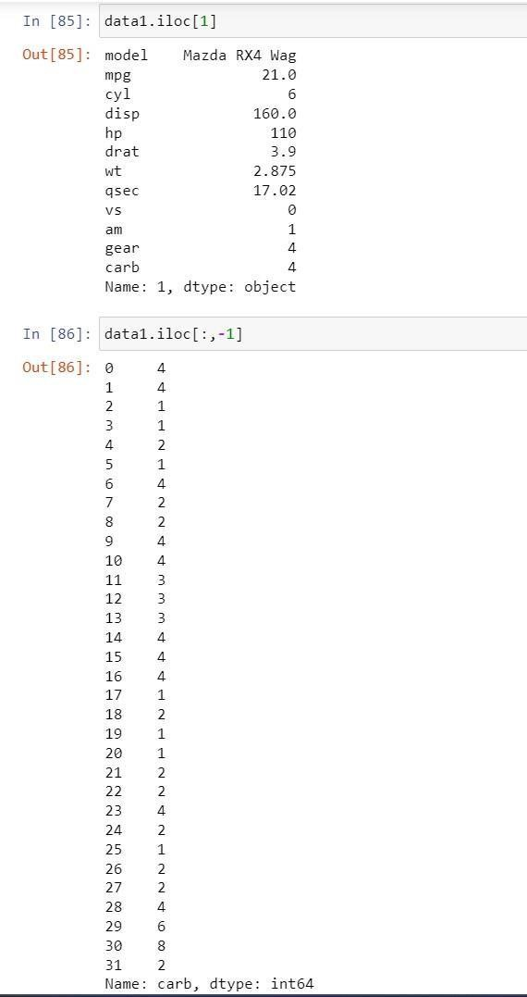

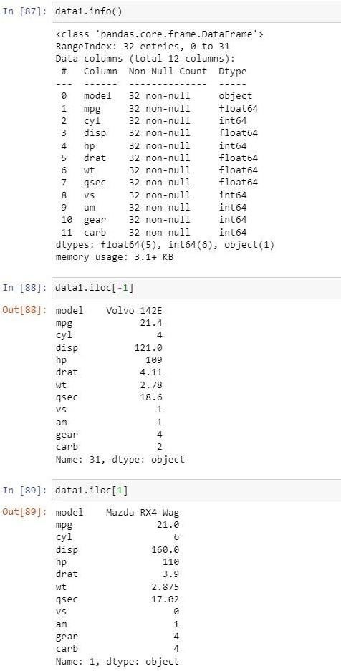

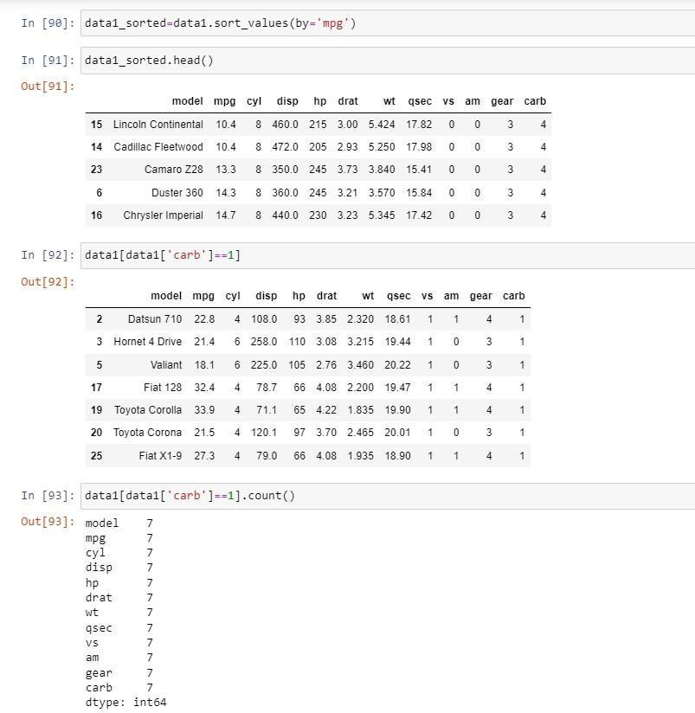

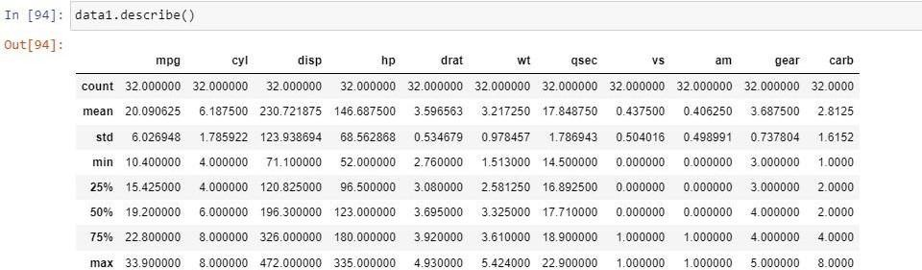

# Practical 3 Supervised Learning

**Problem Statement 3.1 Write a program to implement Linear Regression. Linear Regression**

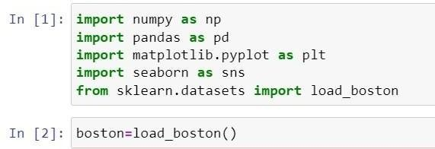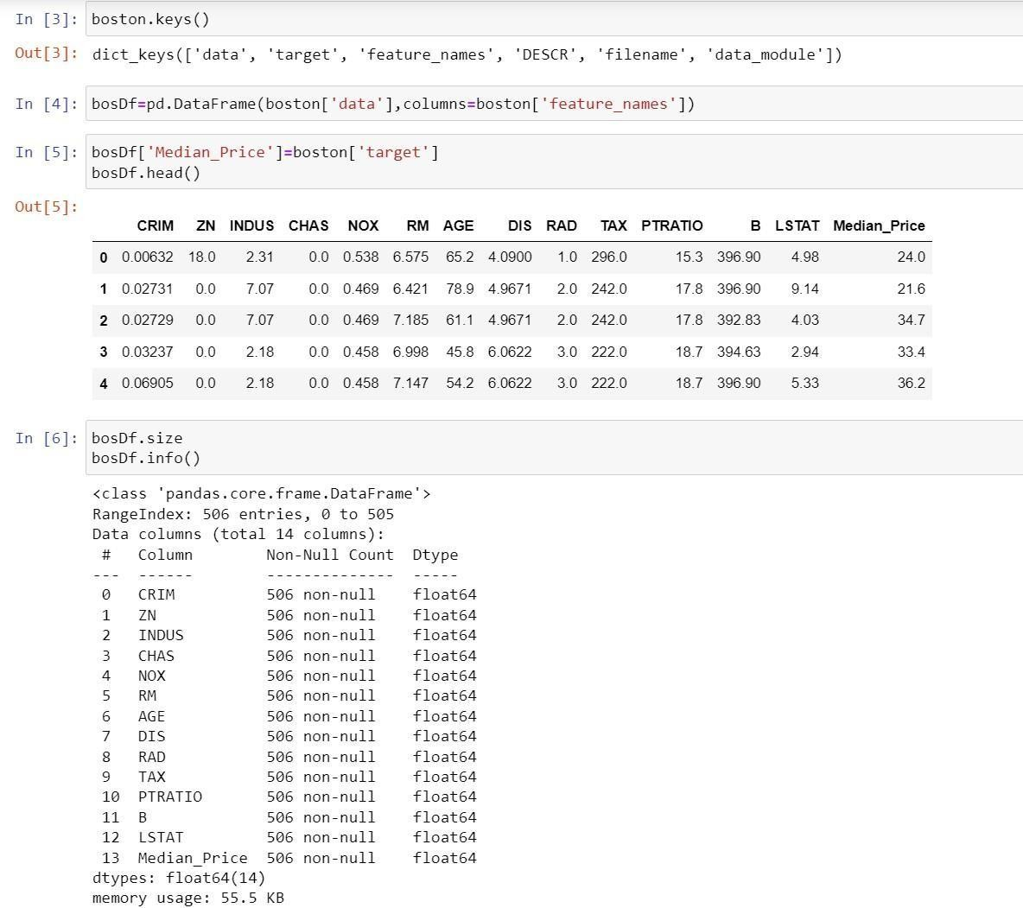

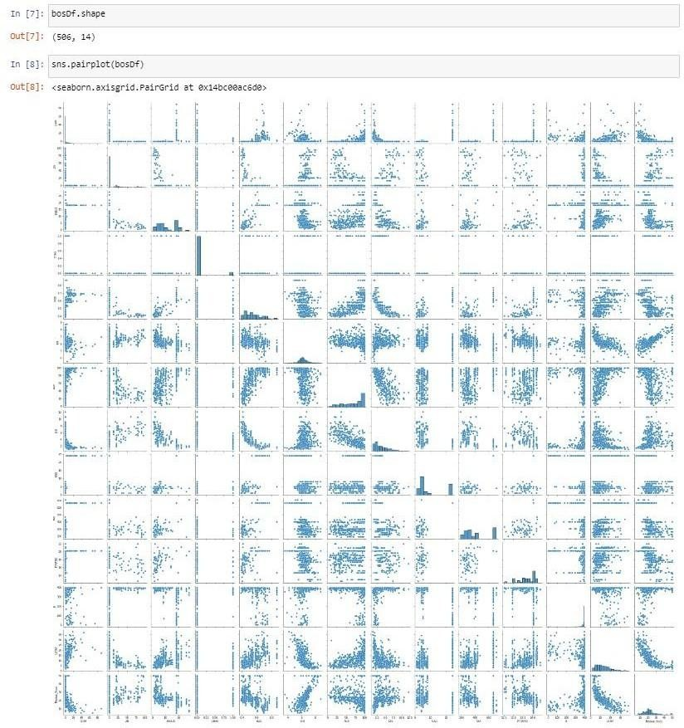

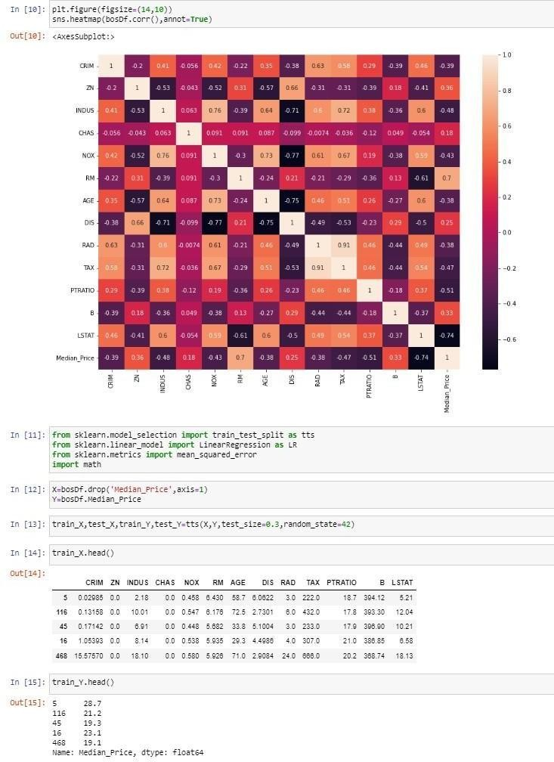

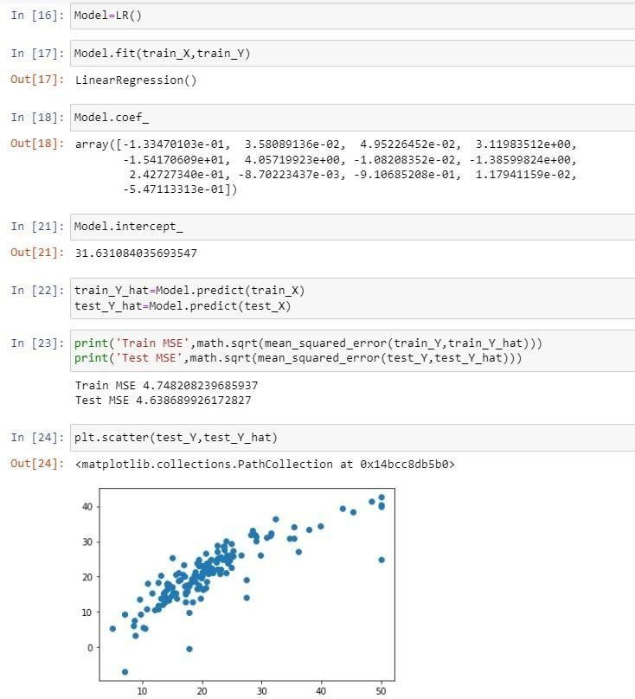

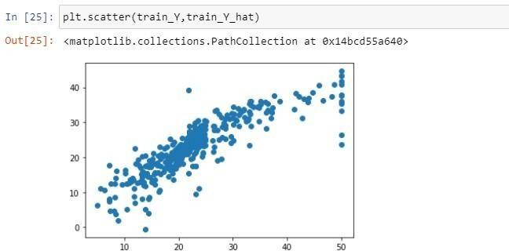

**Problem Statement 3.2 Write a program to implement Logistic regression**

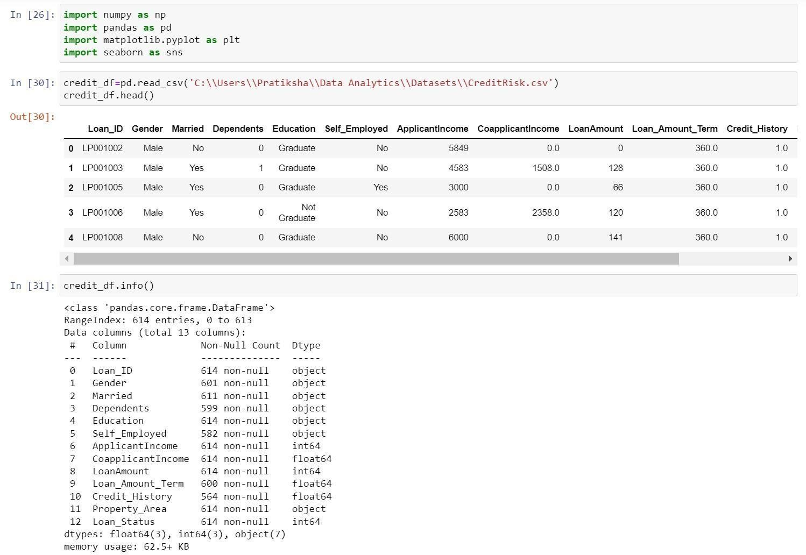

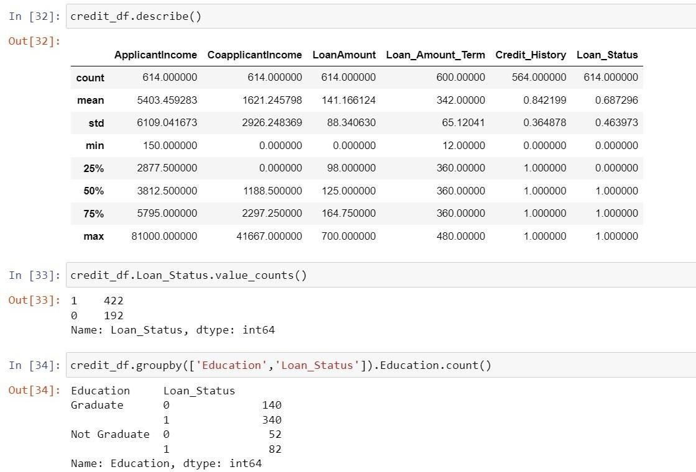

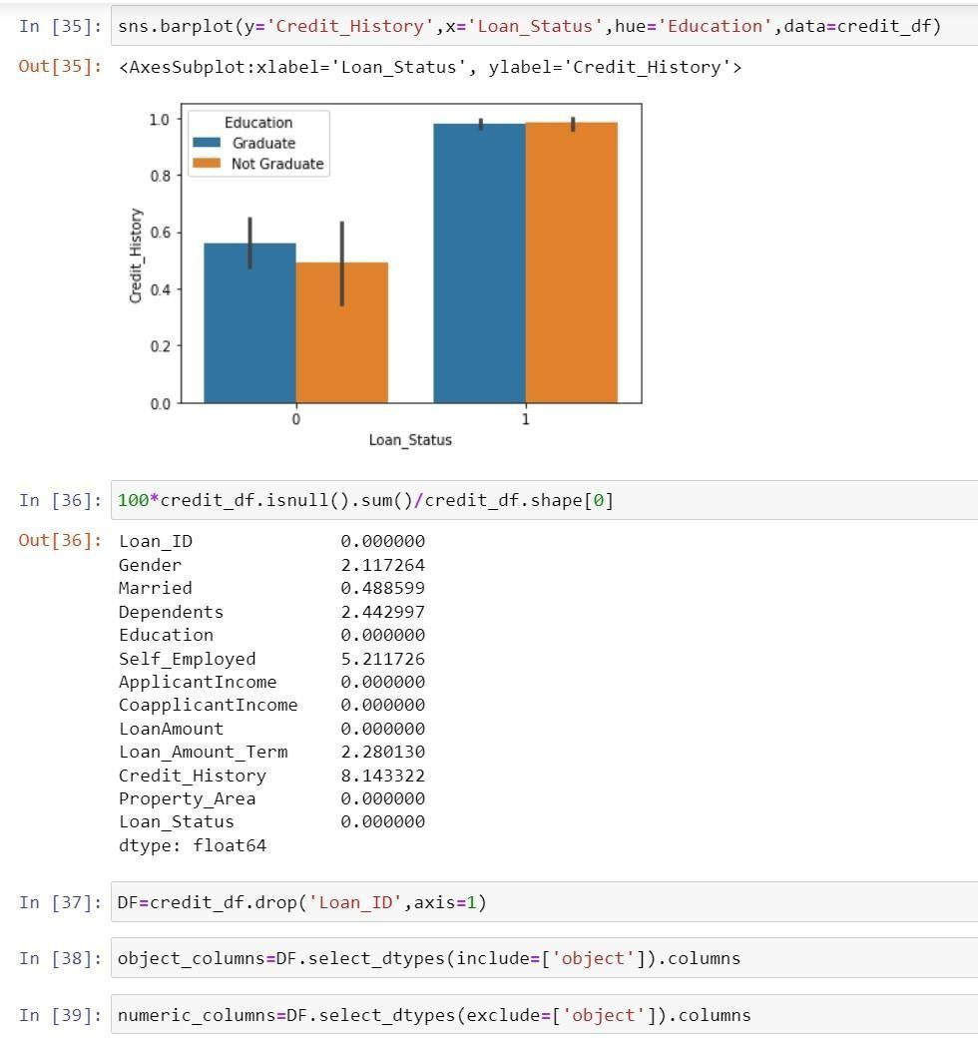

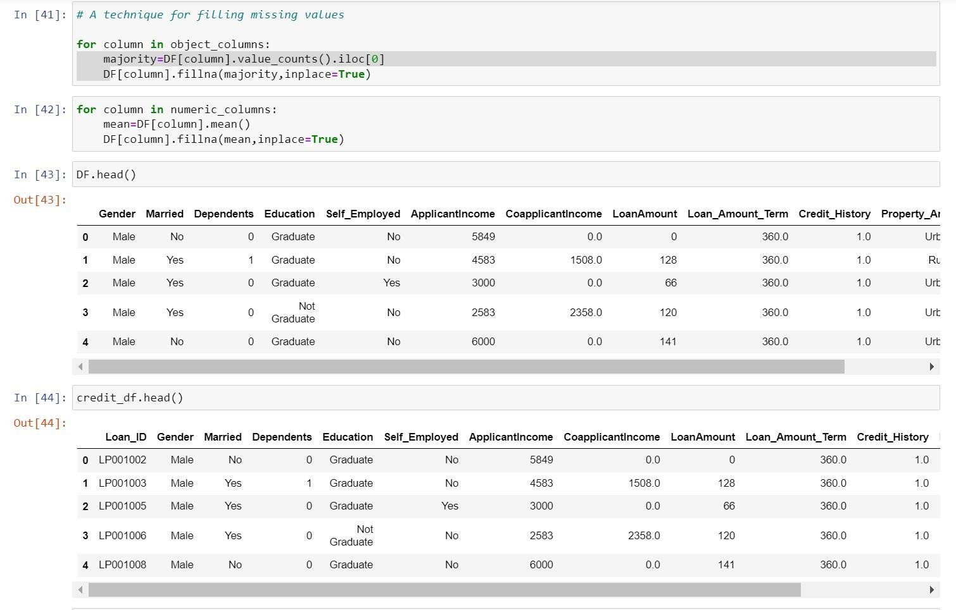

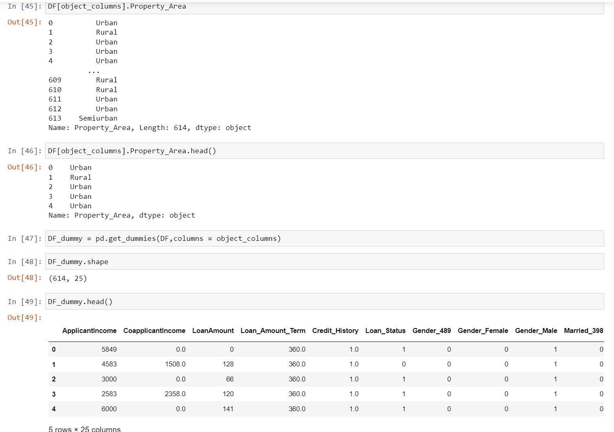

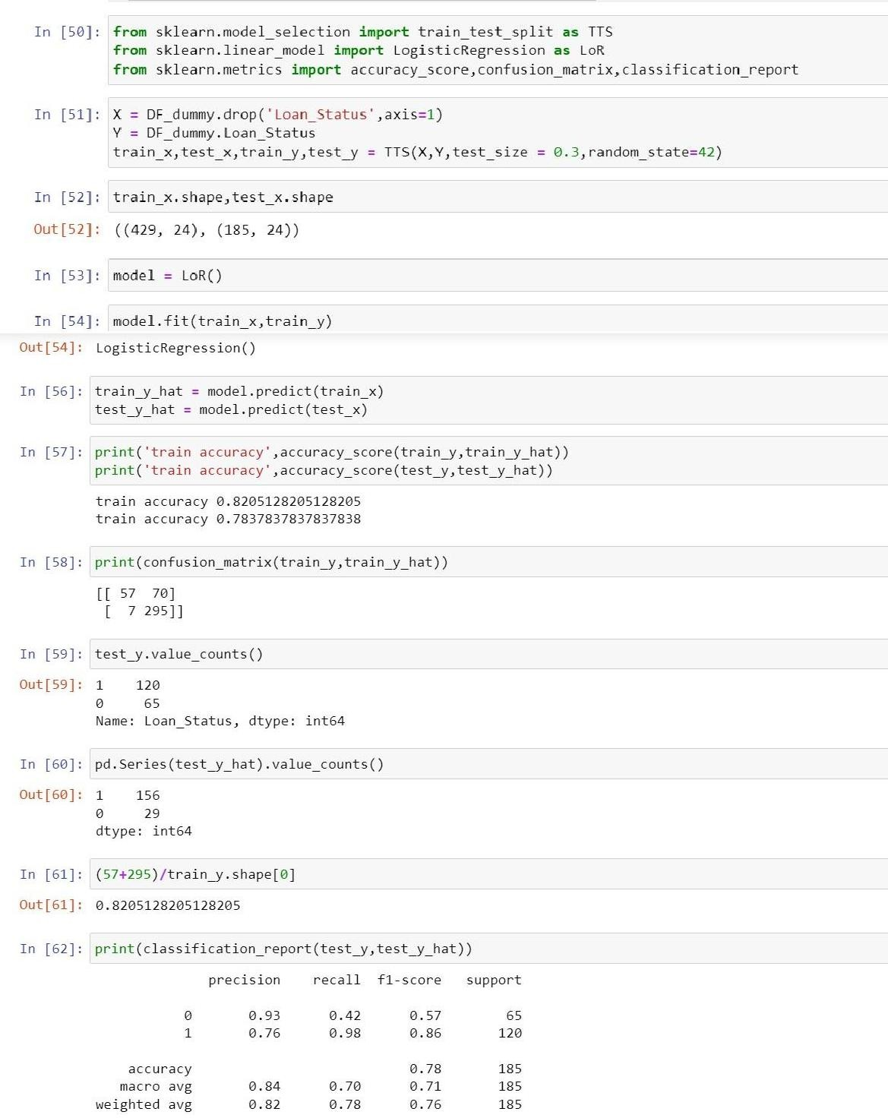

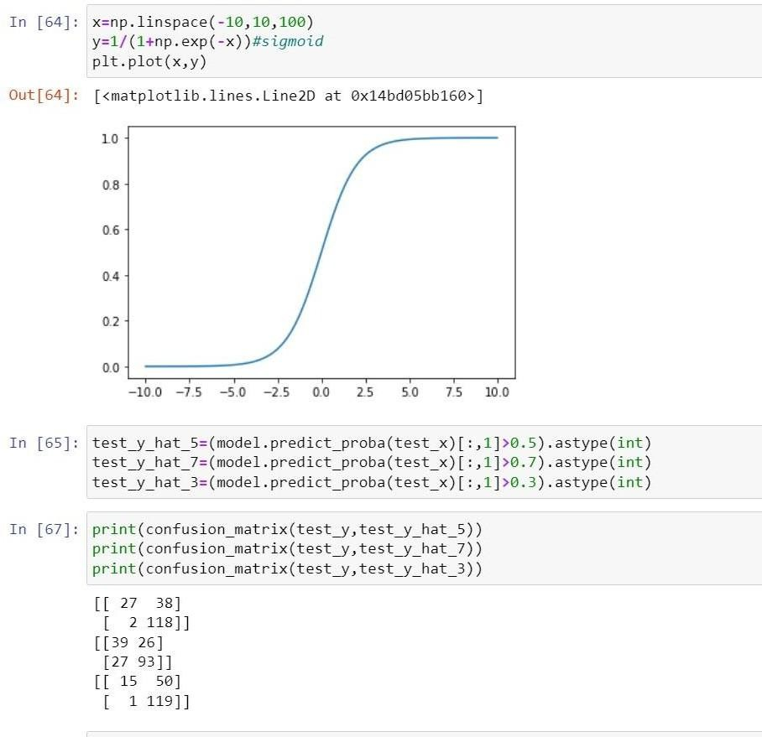

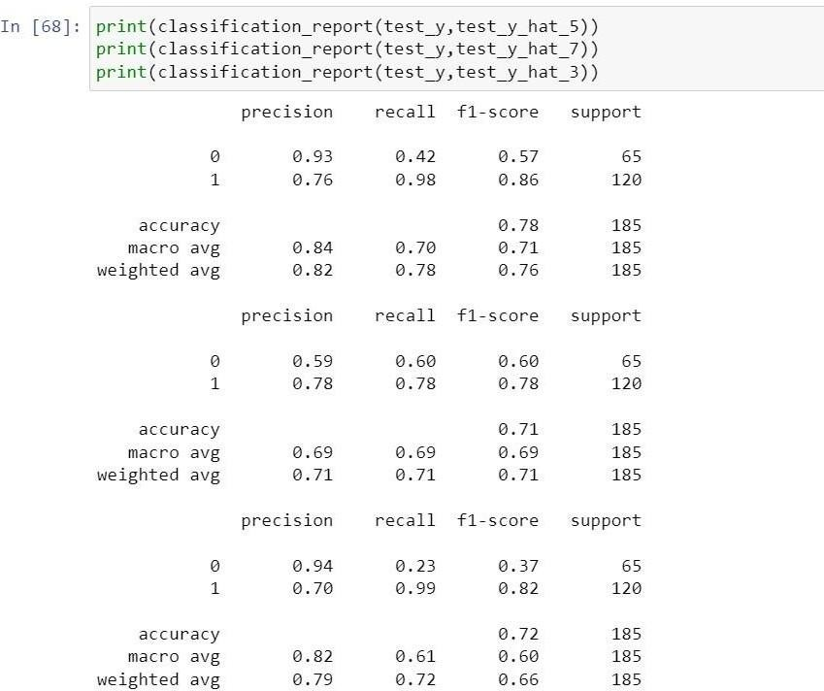

**Problem Statement 3.3: Write a program to implement KNN- classification**

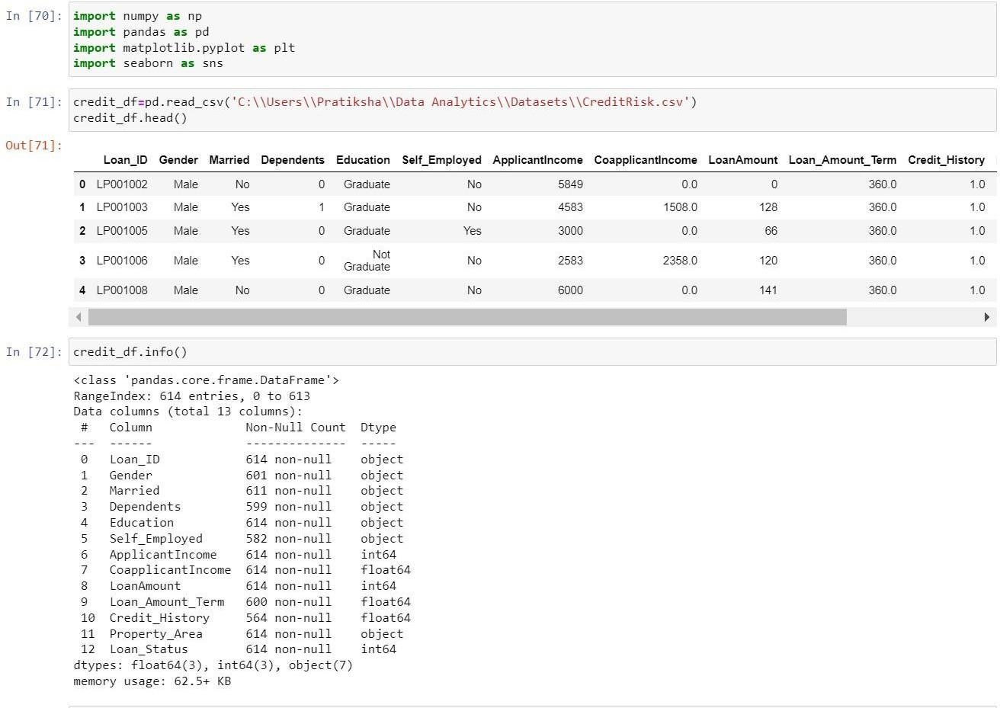

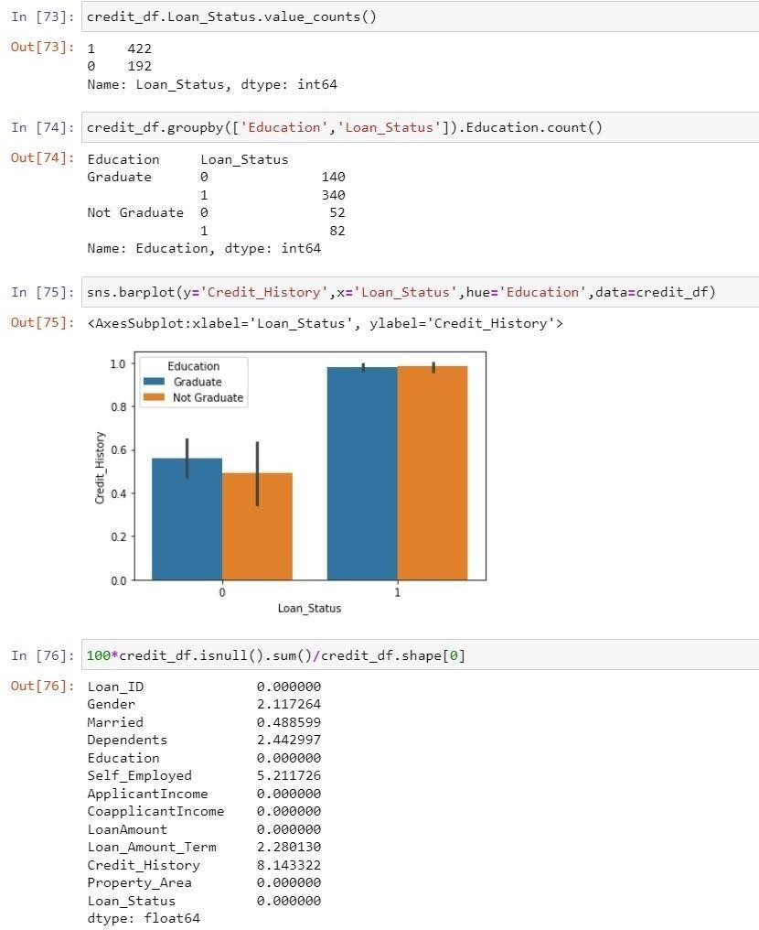

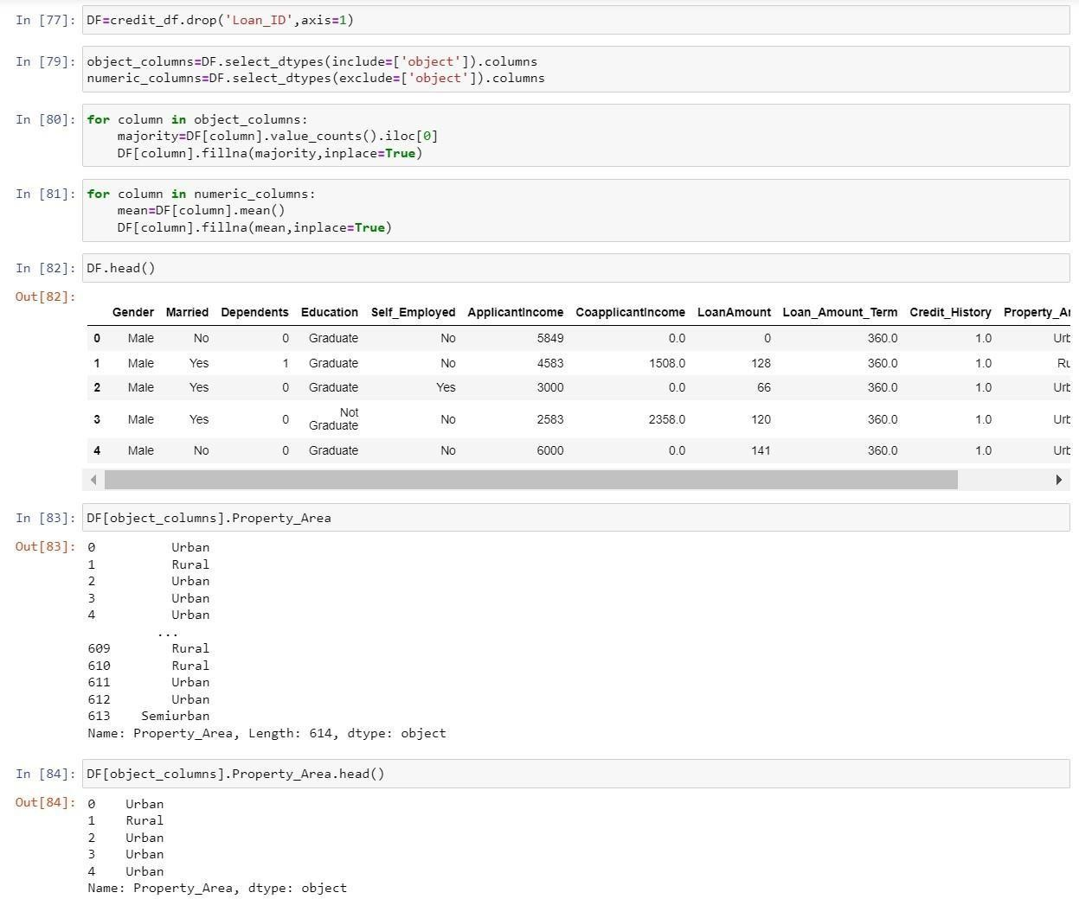

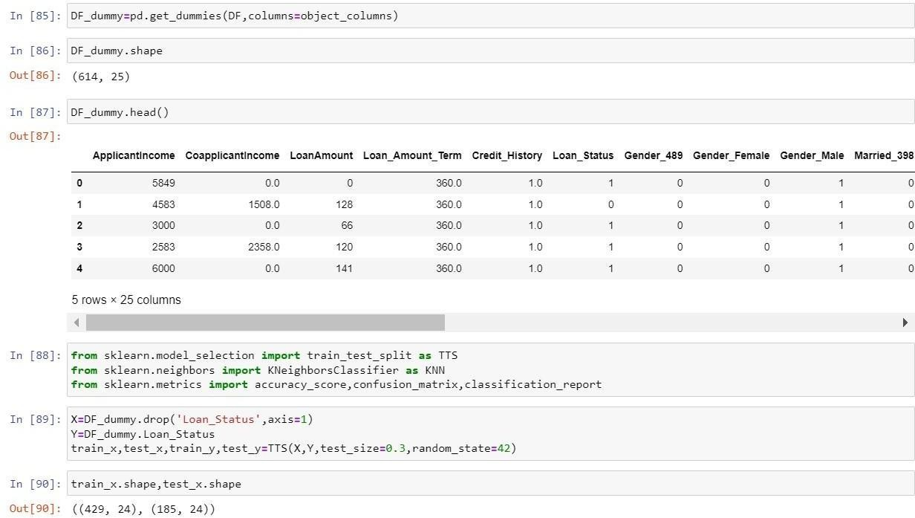

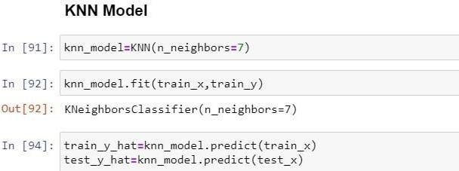

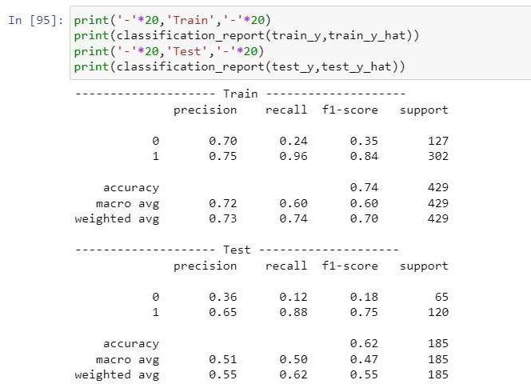

# Practical 4 Unsupervised Learning

**Problem Statement 4.1 Write a program to implement K-Means clustering algorithm.**

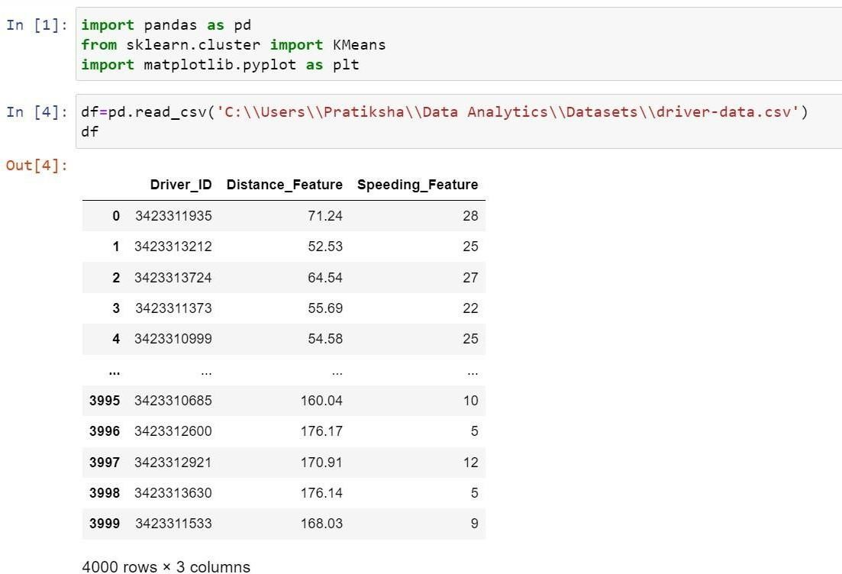

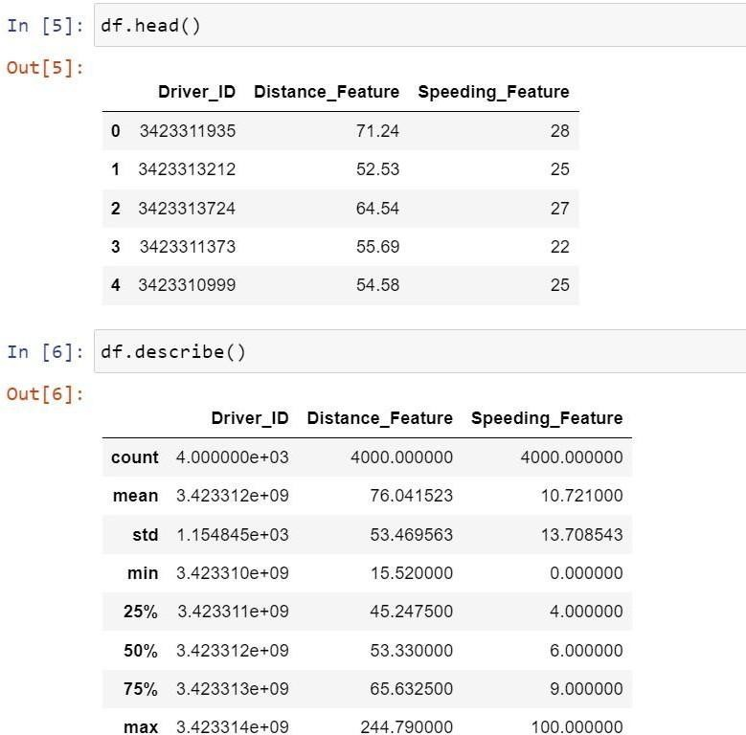

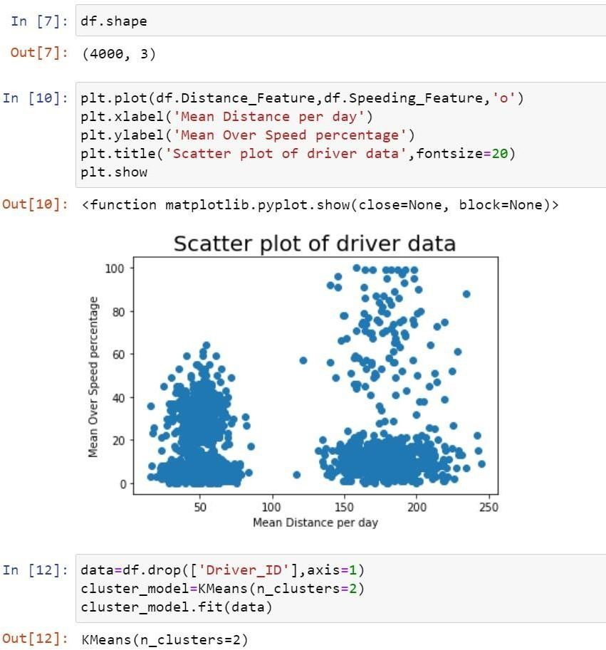

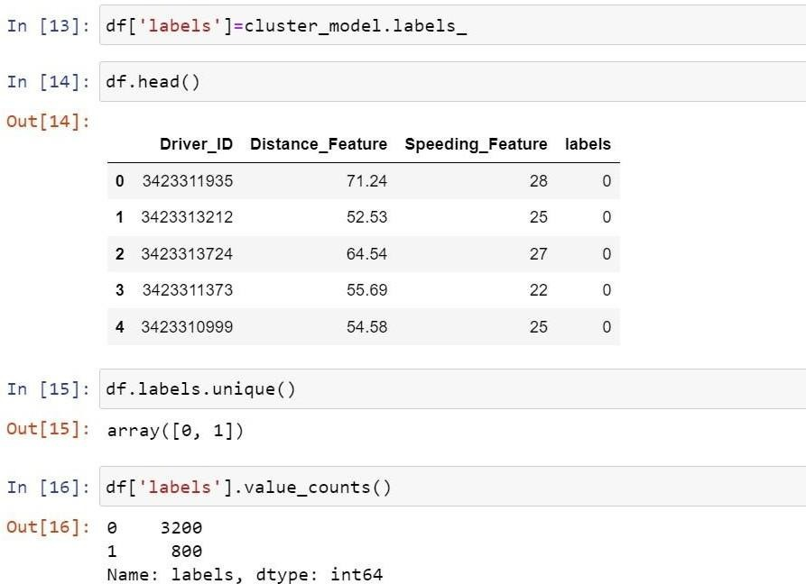

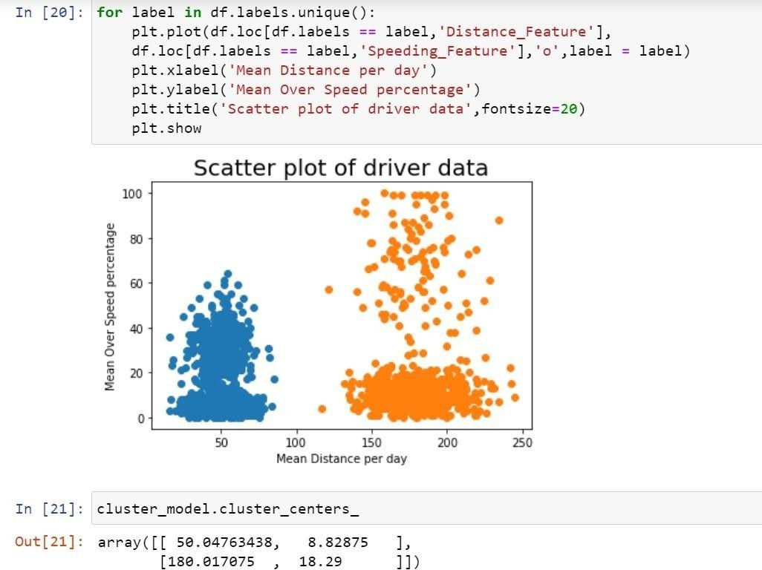

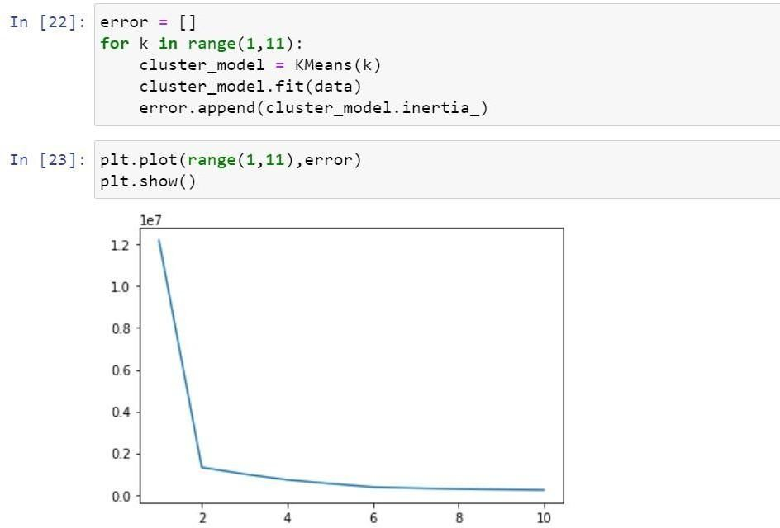

**Problem statement 4.2: Write a program to implement K-medoid clustering algorithm Code:** import

numpy as np

import matplotlib.pyplot as plt plt.style.use("seaborn-whitegrid")

class KMedoidsClass: def

init (self,data,k,iters):

self.data= data self.k = k self.iters = iters

self.medoids = np.array([data[i] for i in range(self.k)])

self.colors = np.array(np.random.randint(0, 255, size =(self.k, 4)))/255 self.colors[:,3]=1

def manhattan(self,p1, p2): return np.abs((p1[0]- p2[0])) + np.abs((p1[1]-p2[1]))

def get_costs(self, medoids, data): tmp_clusters

= {i:[] for i in range(len(medoids))} cst = 0 for d in data:

dst = np.array([self.manhattan(d, md) for md in medoids]) c = dst.argmin() tmp_clusters[c].append(d)

cst+=dst.min()

tmp_clusters = {k:np.array(v) for k,v in tmp_clusters.items()} return tmp_clusters, cst

def fit(self):

samples,_ = self.data.shape

self.clusters, cost = self.get_costs(data=self.data, medoids=self.medoids) count = 0

colors = np.array(np.random.randint(0, 255, size =(self.k, 4)))/255 colors[:,3]=1

plt.title(f"Step : 0")

[plt.scatter(self.clusters[t][:, 0], self.clusters[t][:, 1], marker="*", s=100, color = colors[t]) for t in range(self.k)]

plt.scatter(self.medoids[:, 0], self.medoids[:, 1], s=200, color=colors) plt.show()

while True:

swap = False for i in range(samples): if not i in

self.medoids: for j in range(self.k):

tmp_meds = self.medoids.copy()

tmp_meds[j] = i

clusters_, cost_ = self.get_costs(data=self.data, medoids=tmp_meds) if cost_<cost:

self.medoids = tmp_meds

cost = cost_

swap = True self.clusters

= clusters_

print(f"Medoids Changed to: {self.medoids}.") plt.title(f"Step : {count+1}")

[plt.scatter(self.clusters[t][:, 0], self.clusters[t][:, 1], marker="*", s=100, color = colors[t]) for t in range(self.k)]

plt.scatter(self.medoids[:, 0], self.medoids[:, 1], s=200, color=colors)

plt.show()

count+=1

if count>=self.iters: print("End of the iterations.") break if not swap:

print("No changes.")

break

dt = np.random.randint(0,100, (100,2)) kmedoid

= KMedoidsClass(dt,5,5) kmedoid.fit()

**Output:**

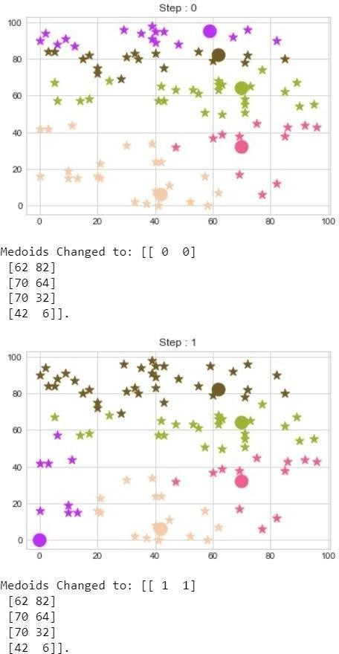

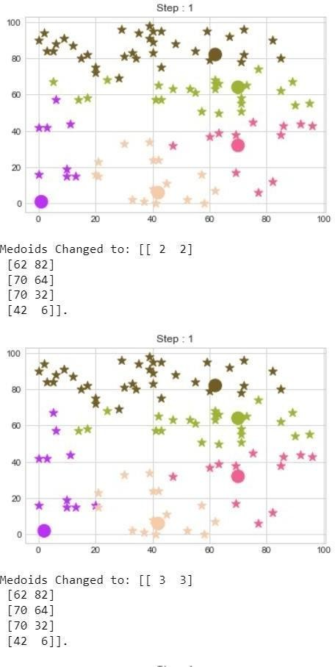

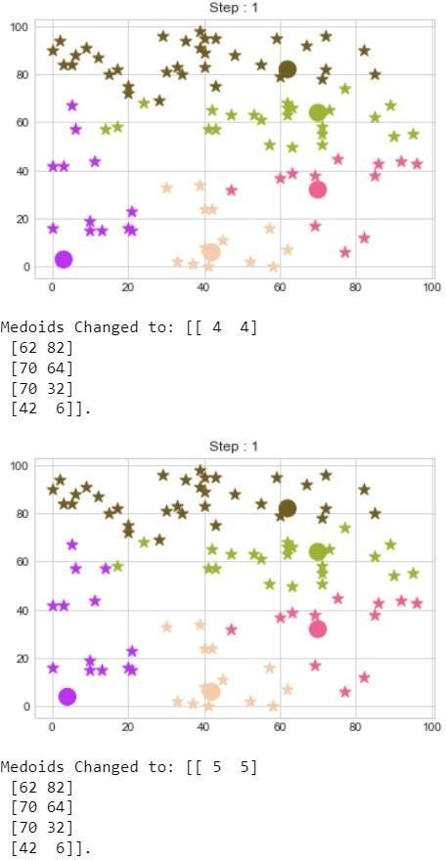

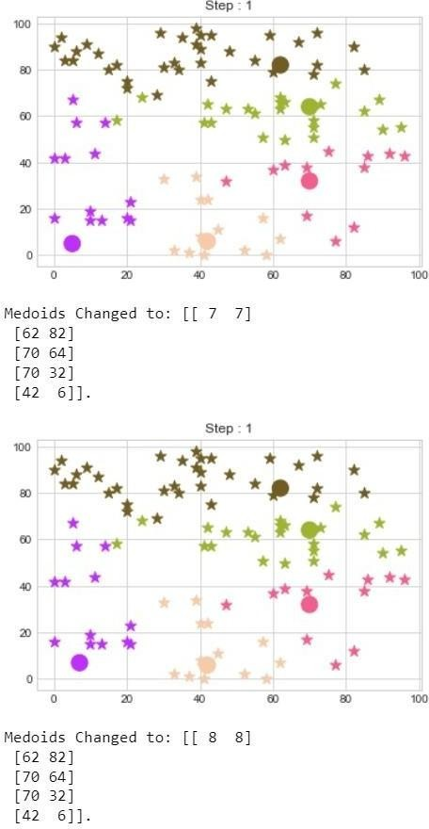

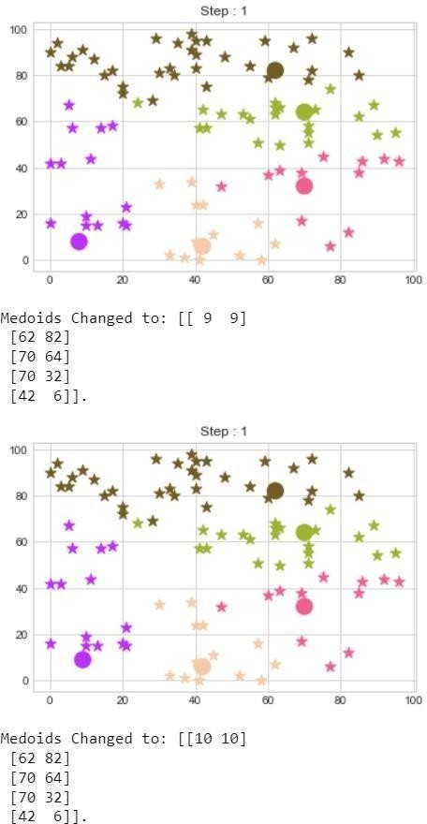**.**

**.**

**.**

**.**

**.**

**.**

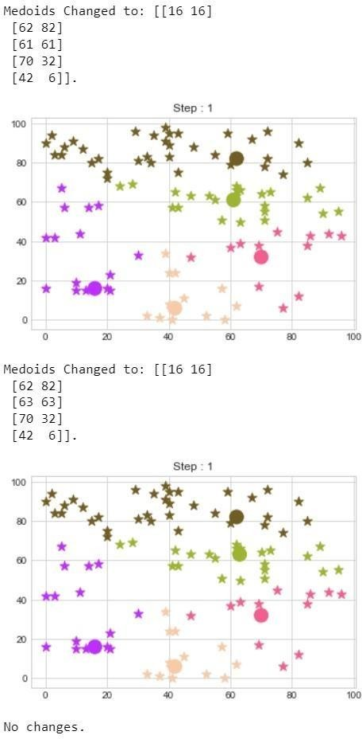**.**

# Practical 5

**Classifying data using Support Vector Machines (SVMs)**

**Problem Statement 5.1 Write a program to Classifying data using Support Vector Machines (SVMs).**

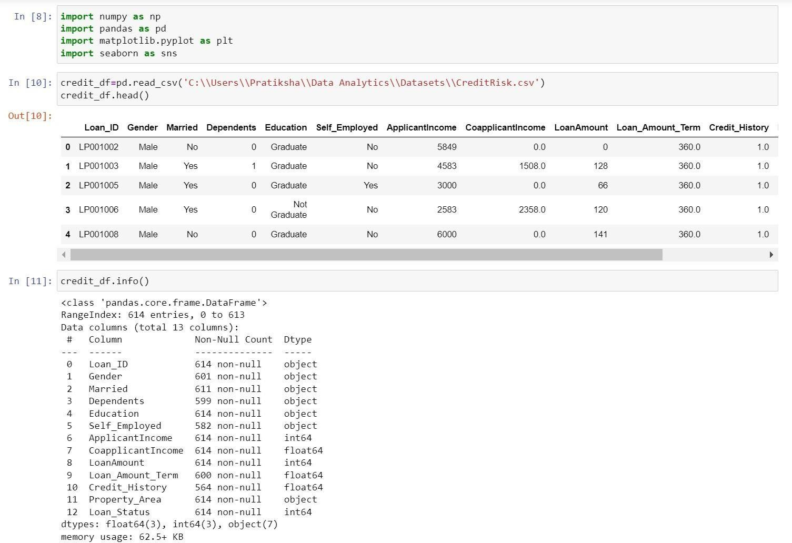

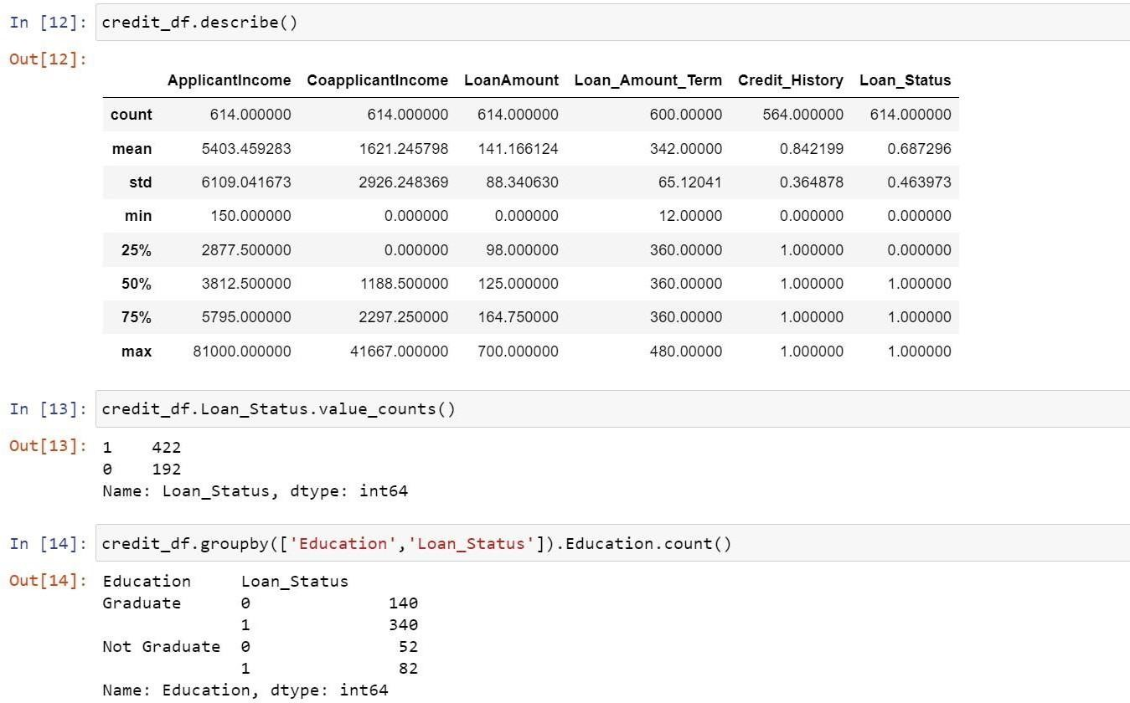

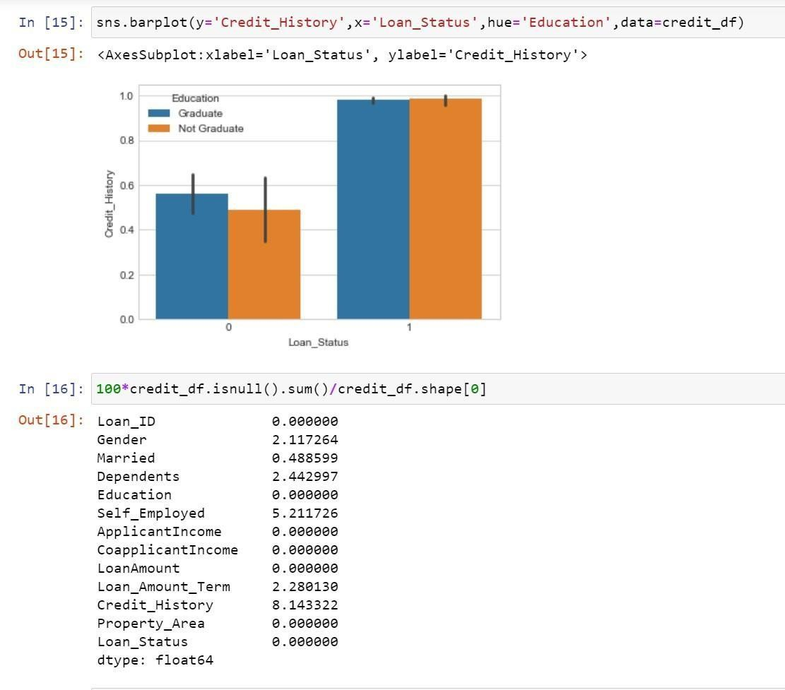

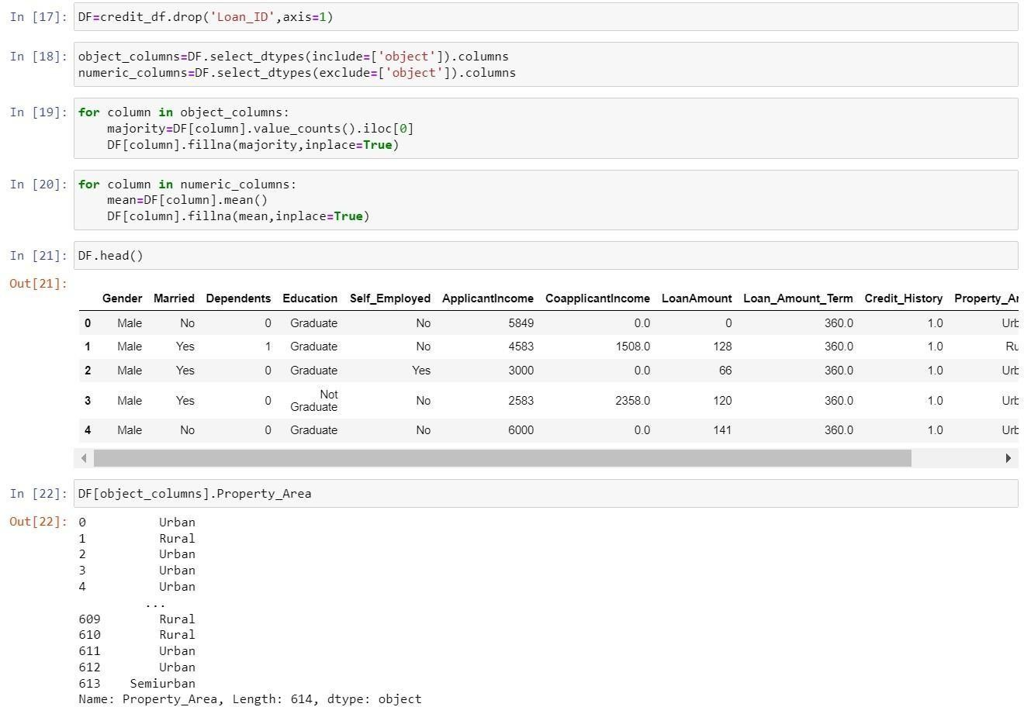

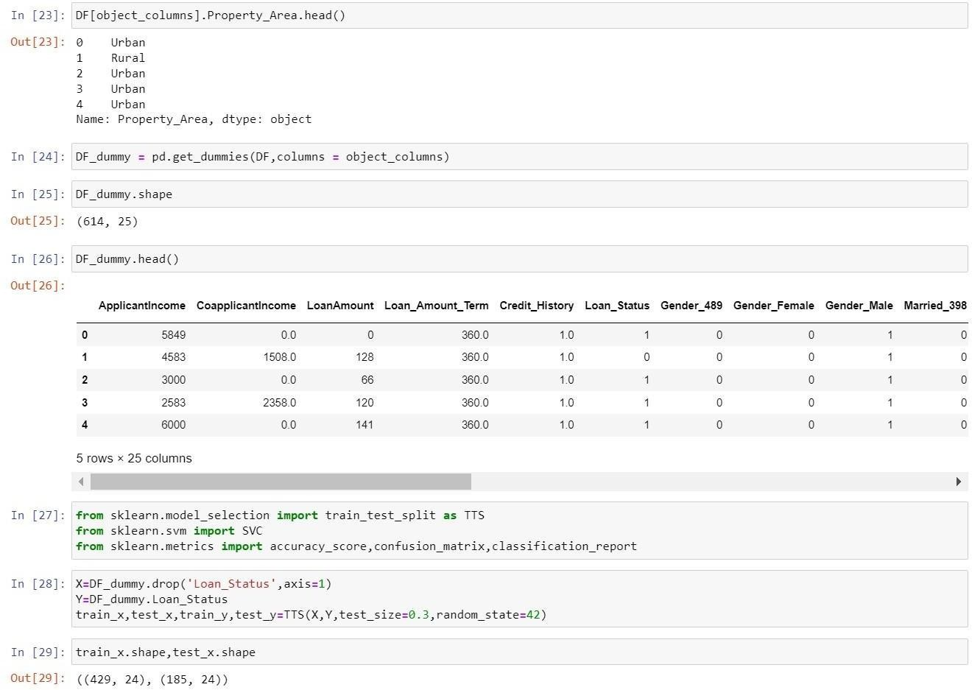

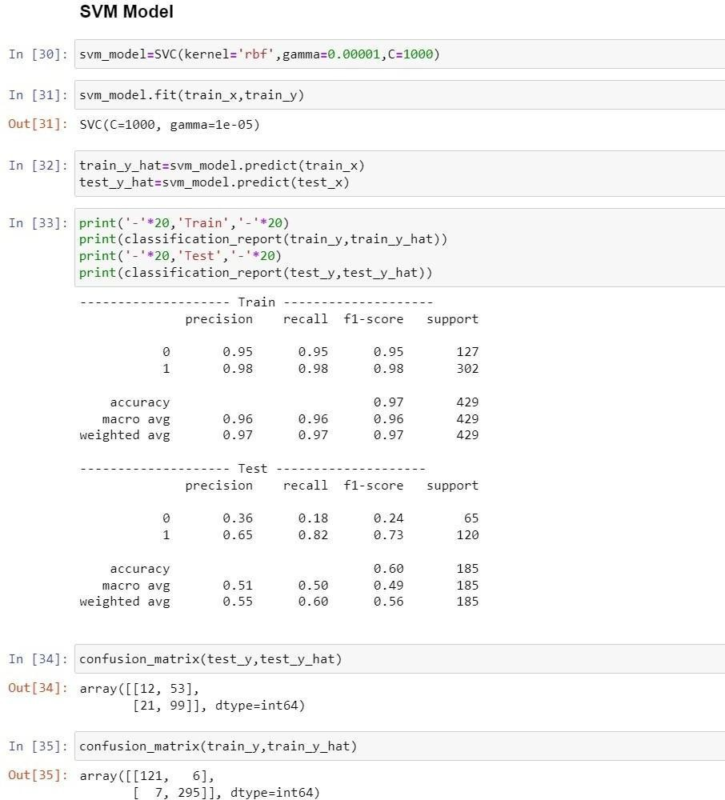

# Practical 6 Bagging Algorithm

**Problem Statement 6.1 Write a program to implement Bagging Algorithm Decision Tree.**

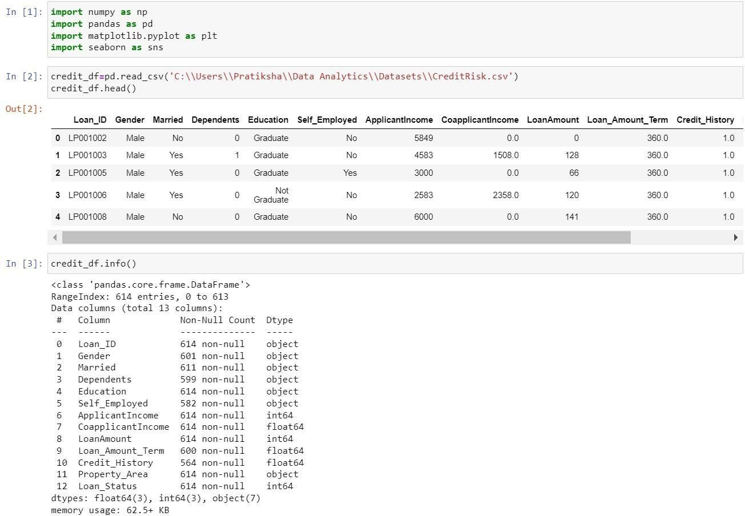

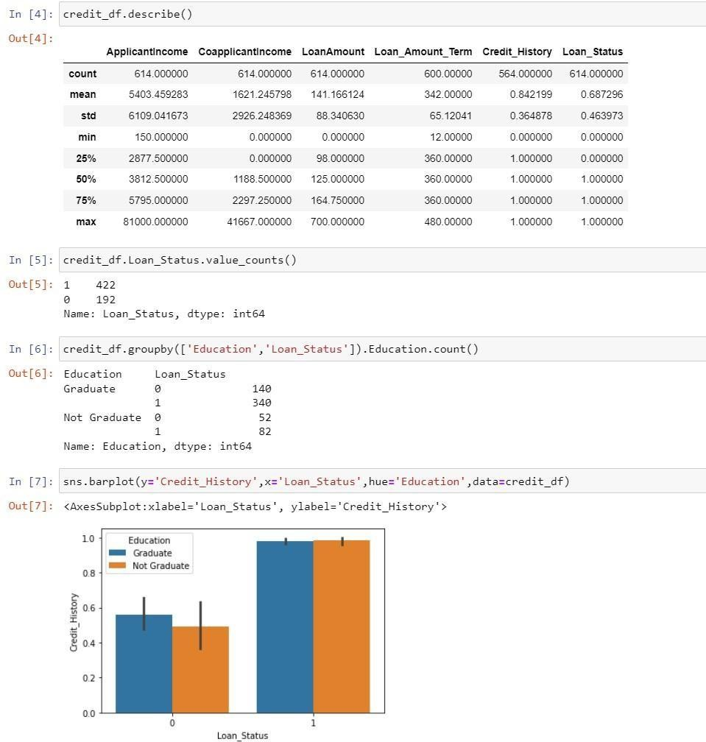

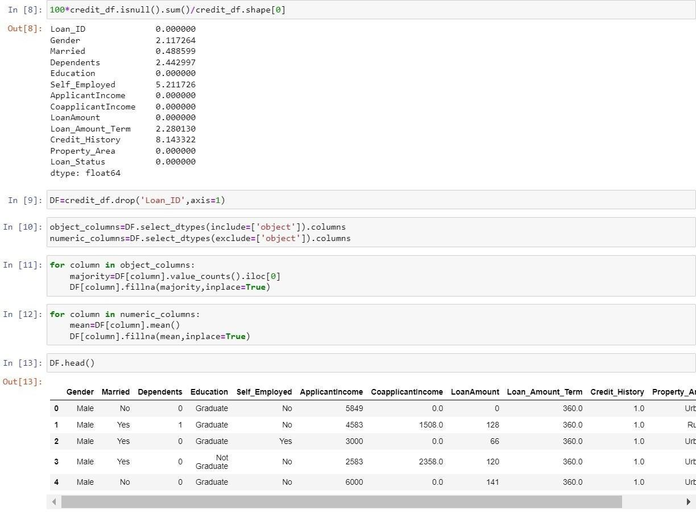

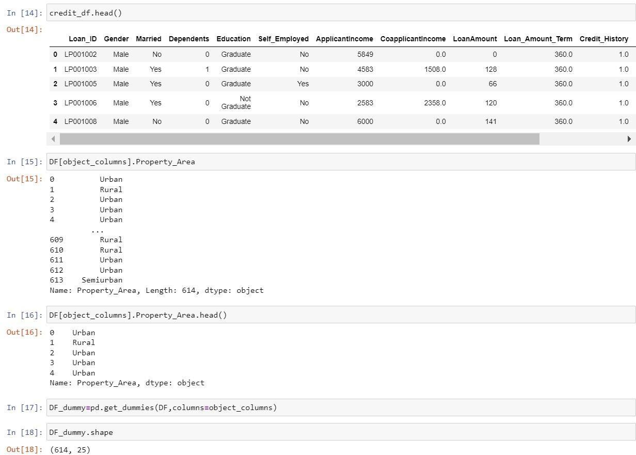

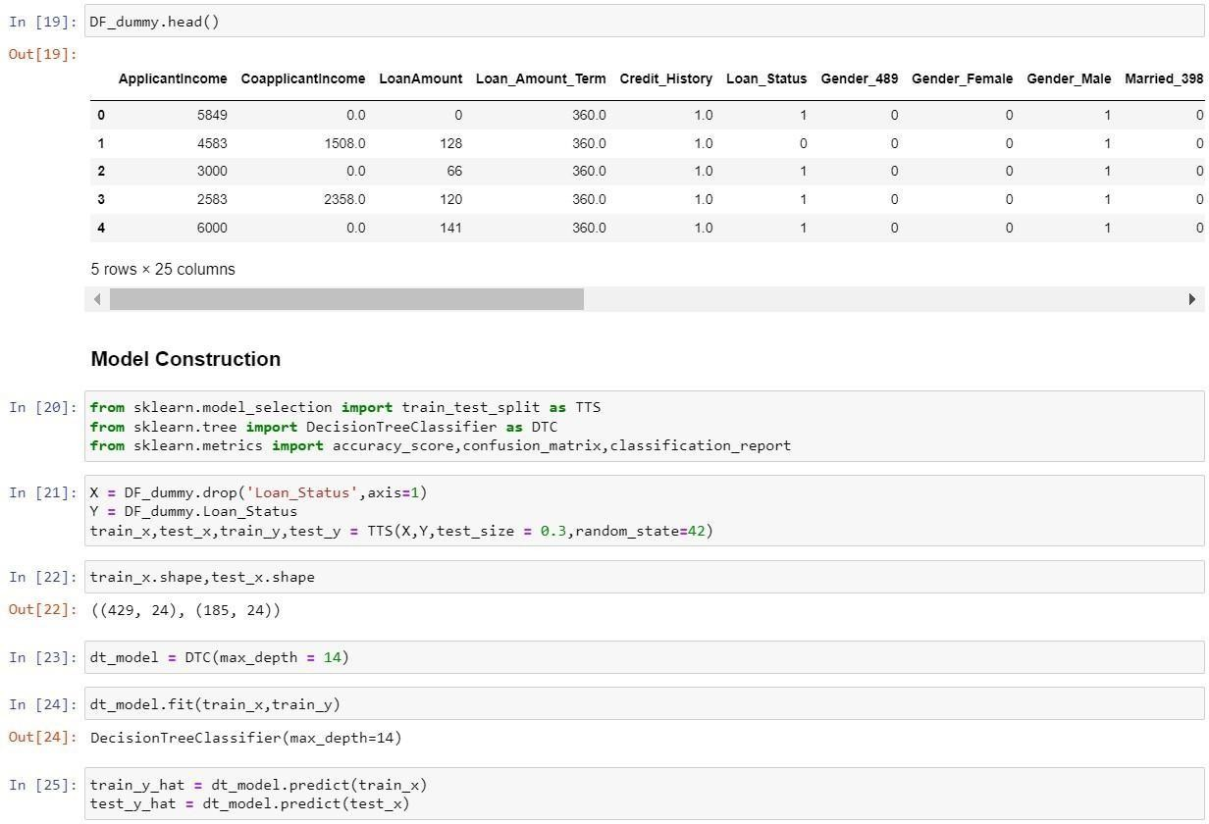

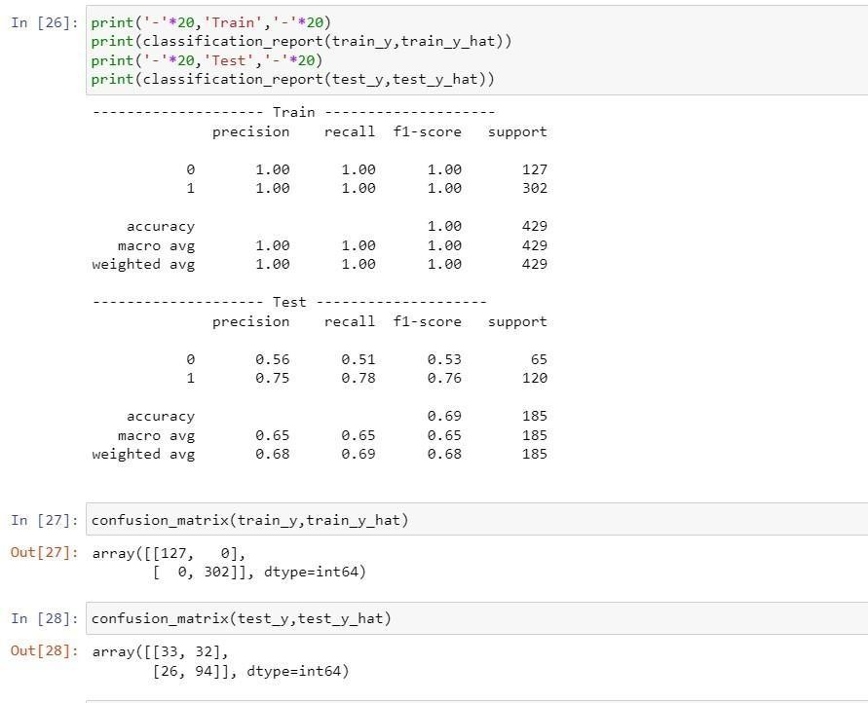

**Problem Statement 6.2 Write a program to implement Bagging Algorithm Random Forest.**

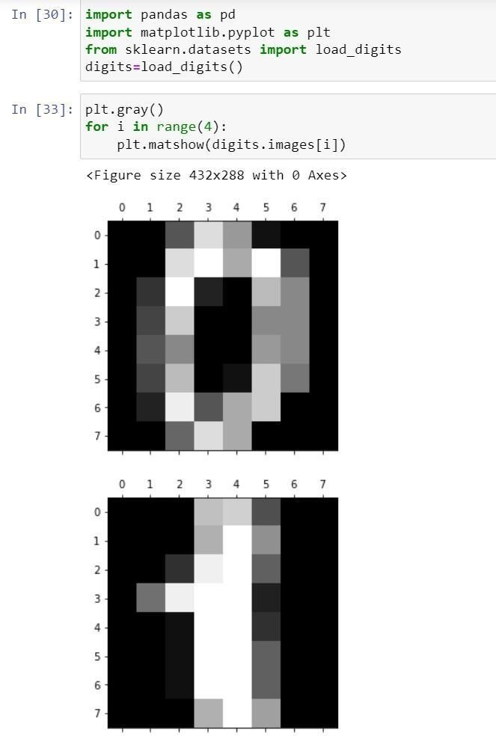

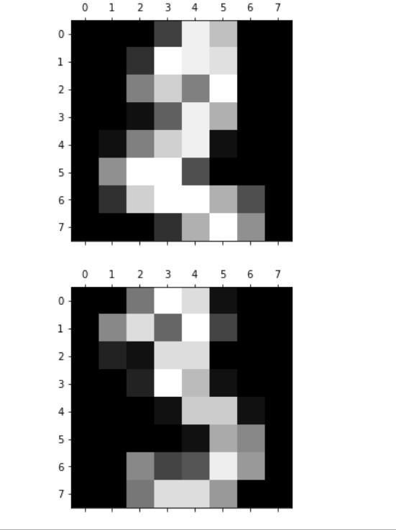

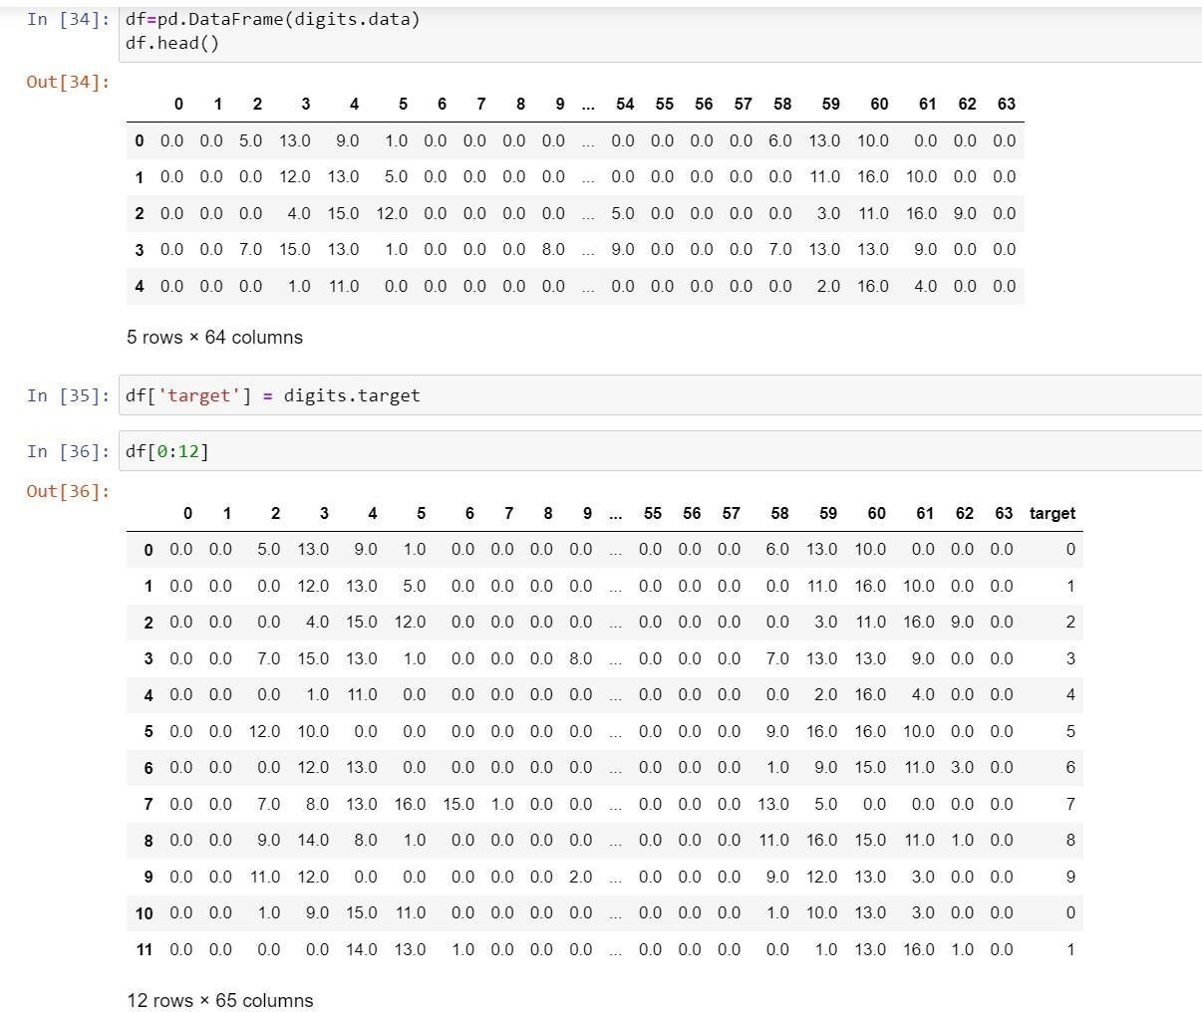

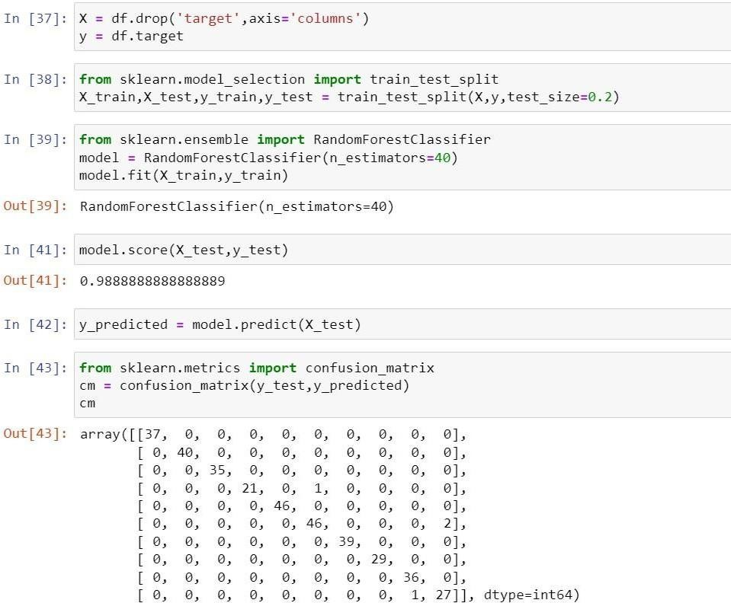

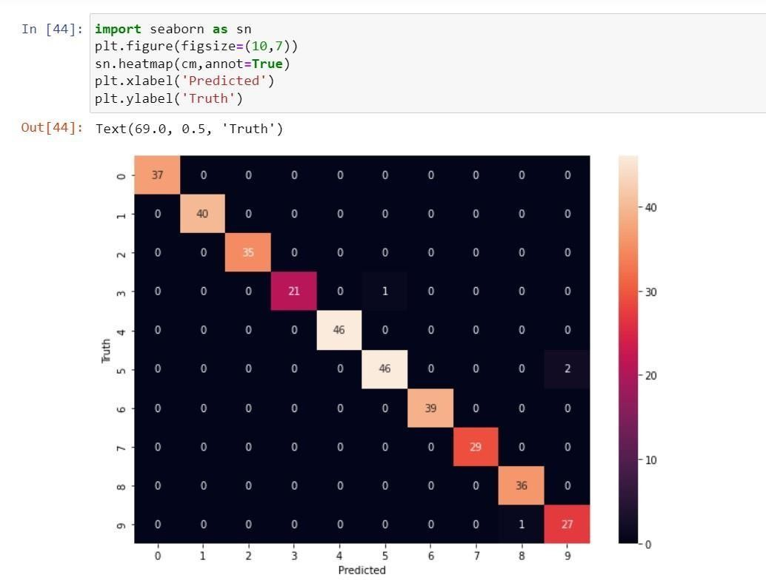

# Practical 7 Boosting Algorithms

**Problem Statement 7.1 Write a program to implement Boosting Algorithms: AdaBoost .**

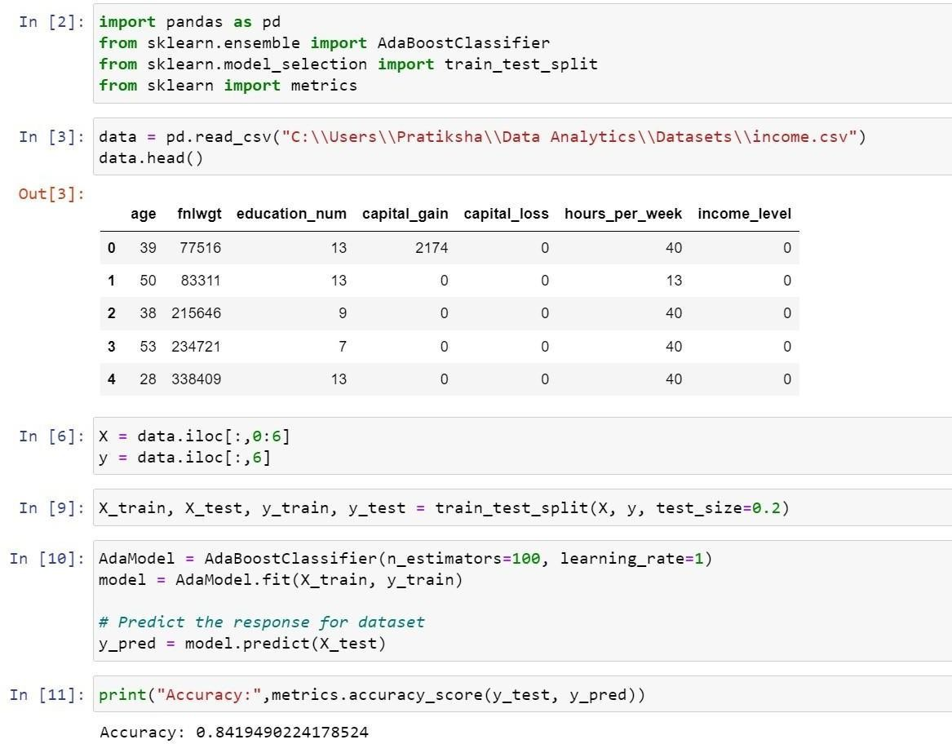

**Problem Statement 7.2 Write a program to implement Boosting Algorithms: Stochastic Gradient Boosting.**

**Stochastic Gradient Boosting:-**

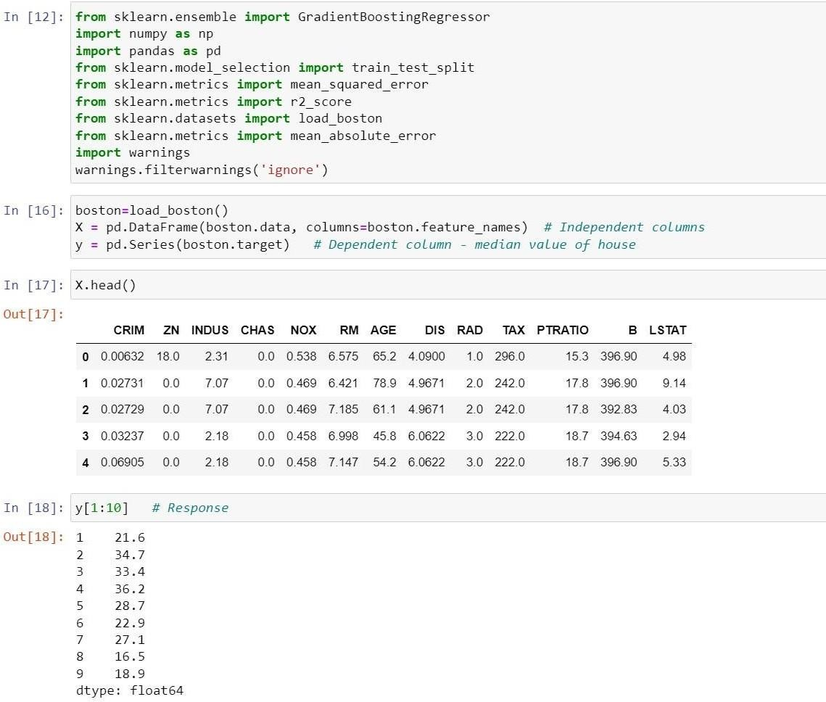

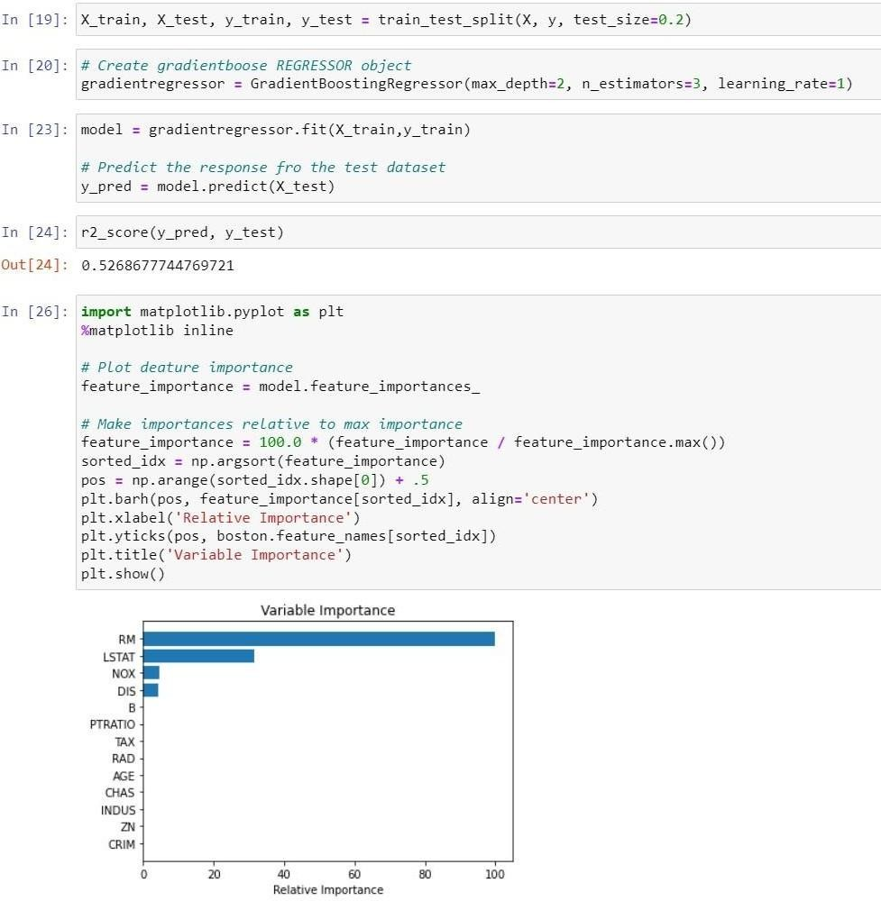

# Practical 8

**Deployment of Machine Learning Models**

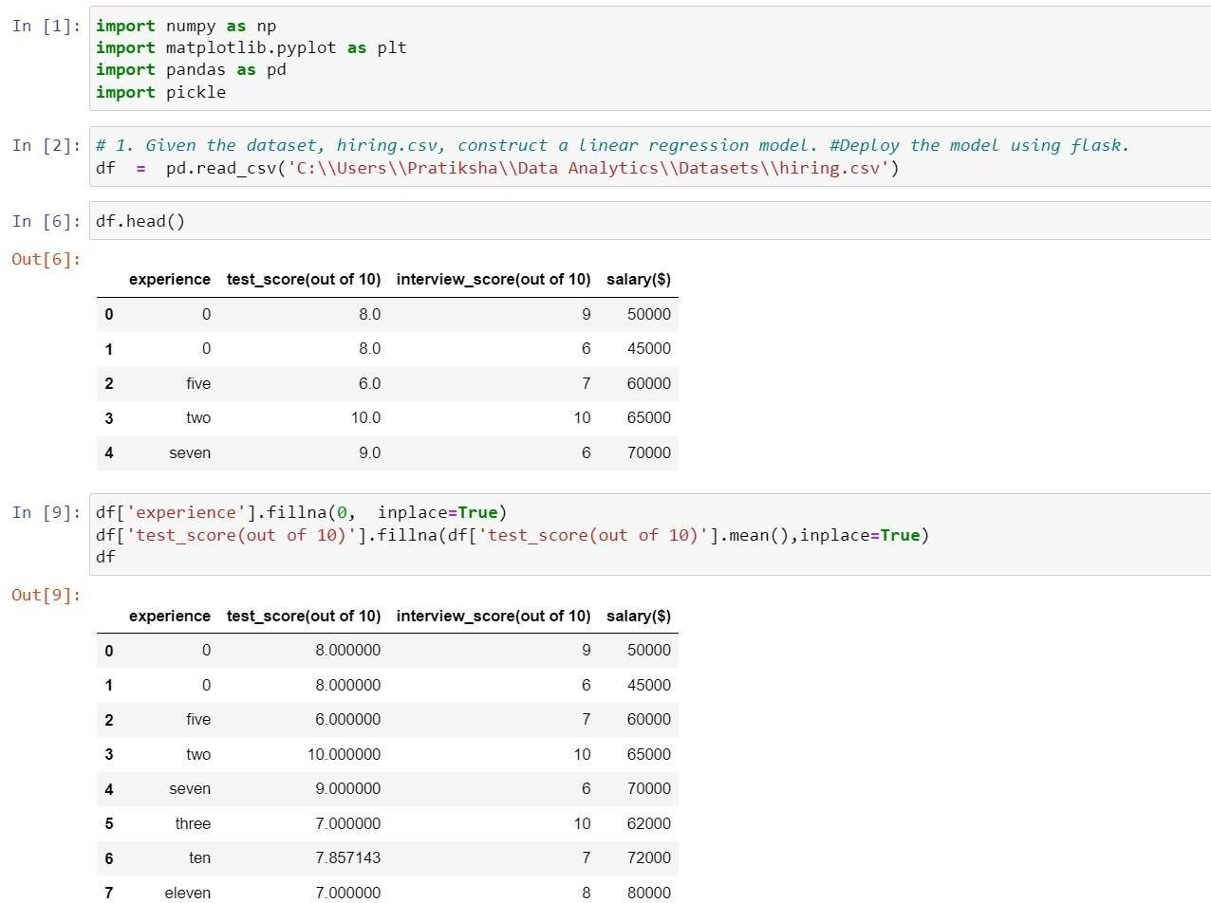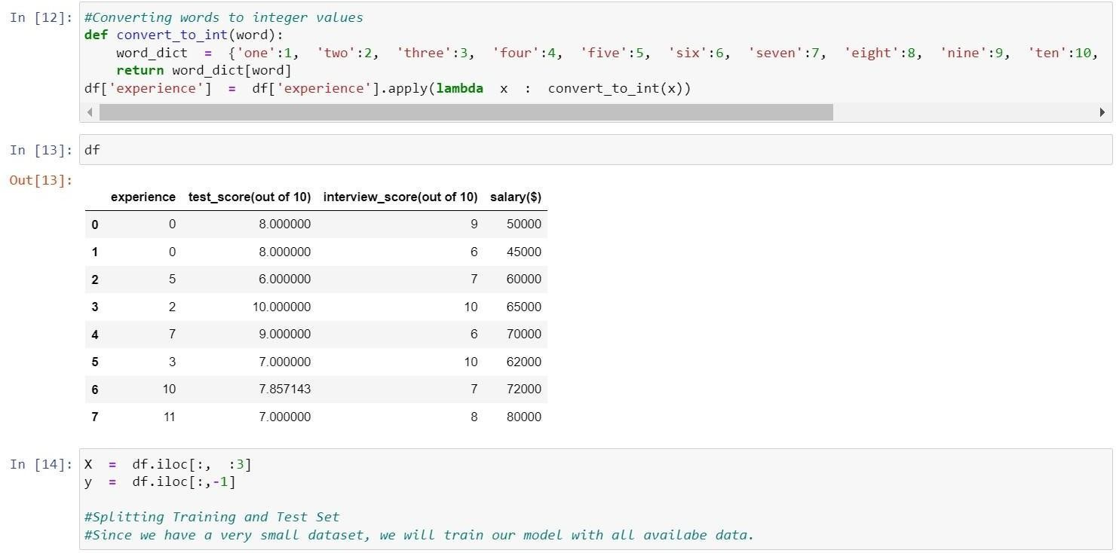

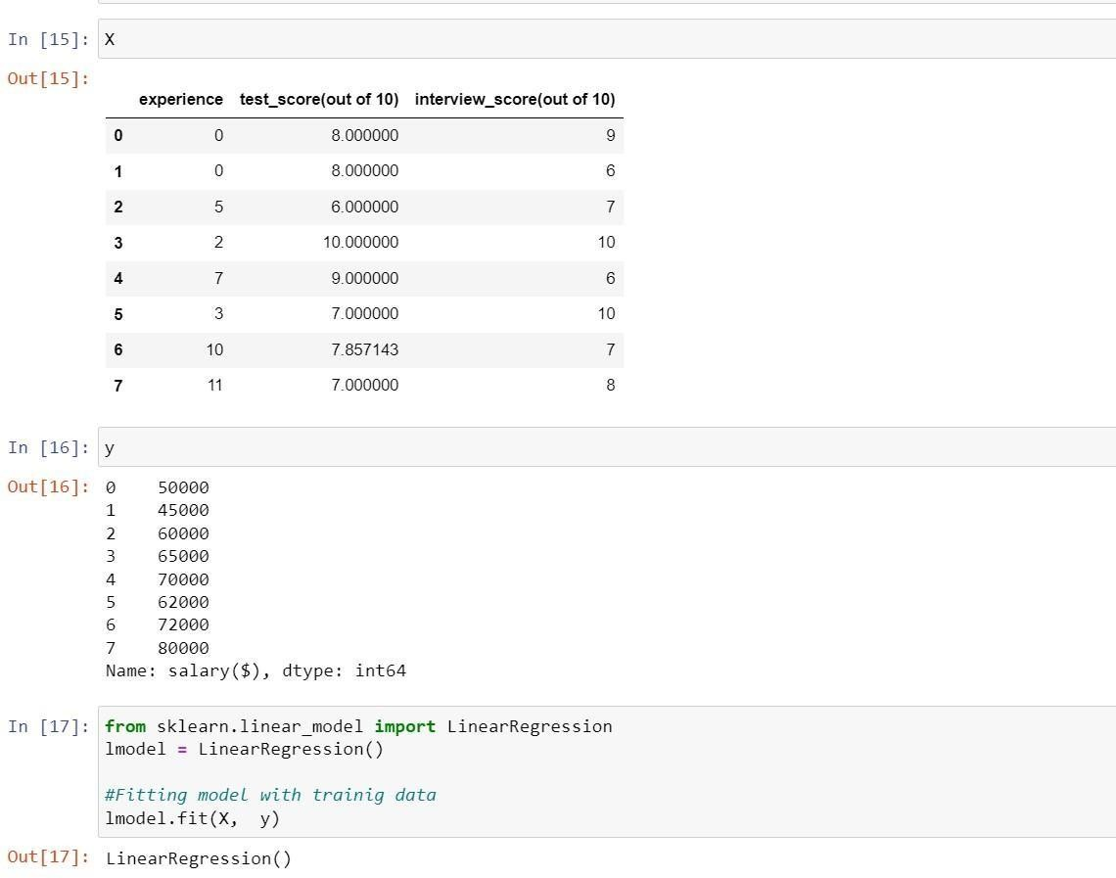

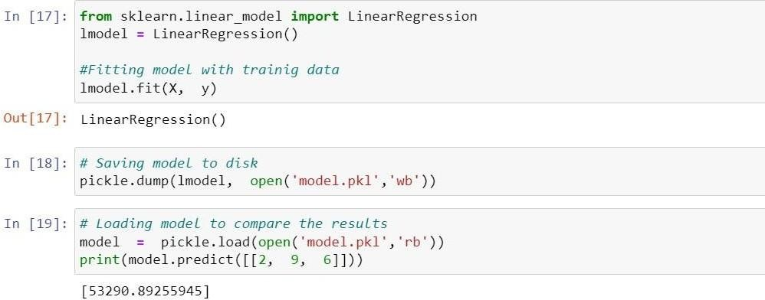

**# 2. Run the model on browser for and predict the salary**

**a.**experience =9, test_score=8 and interview_score=9

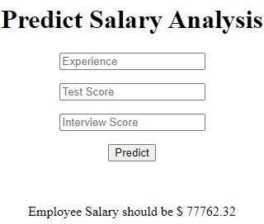

**b.** experience =1, test_score=4 and interview_score=3

